SLP Manual

PROCEDURES AND FORMS MANUAL
FOR THE
SPEECH-LANGUAGE PATHOLOGIST

Tri-County Special Education Association
November 2005
Revisions: June 2011, Fall 2014,
Fall 2015

Joyce Dachauer Scott Hogan, Ed.D
Supervising SLP Executive Director

Table of Contents: Page 1

Introduction/General Information
Pg. 1 Introduction
Pg. 2 Education/Certification for SLPs
Pg. 3-4 Role and Responsibilities of the SLP
Pg. 5 Confidentiality/In Servicing Staff

Identification Process
Pg. 11 Individual Screening
Pg. 12 Group Screening

Referral Process
Pg. 15-16 Referral for Speech/Language-Only Evaluation
Pg. 17 Referral for A Full Case Study Evaluation
Pg. 18-19 Referrals from Early Intervention

The Evaluation Process
Pg.21 Evaluation: Speech/Language-Only
Pg.22 K.I.D.S. forms for Eligibility Determination Conference:S/L-Only

EDC
Pg. 25 Eligibility Determination Conference: Speech/Language-Only
Pg. 26 Eligibility Determination Conference: S/L as Related or Secondary
Pg. 27-28 Determining Secondary Disability vs. Related Service for S/L

S/L Eligibility Criteria/Matrix/Ratings
Pg. 31-32 Eligibility Determination: Severity Rating Guidelines
Pg. 33-35 Mild/Moderate Eligibility Criteria
Pg. 36-37 Severe/Profound Eligibility Criteria
Pg. 38-40 Factors to Consider when Determining Eligibility
Pg. 41 Severity Definitions
Pg. 42 Signs and Effects of Communication Disorders
Pg. 43 Entry/Exit Criteria for Caseload Selections

Table of Contents: Page 2
Service Delivery Models
Pg. 45 Consultation
Pg. 46 Integrated Services
Pg. 47 Pull-Out/Instructional Services

IEP
Pg.51-52 IEP for Speech/Language-Only
Pg. 53 IEP for Speech/Language as Related or Secondary
Pg. 54 Misc. Information about IEP Content/Procedures/ILS & NILS
Pg. 55 Suggested Agenda for IEP Meetings
3 Year Re-Evaluation
Pg. 61-62 3-Year Re-Evaluation

Termination: Speech/Language Services
Pg. 65-67 Consideration of Termination of Speech/Language Services

Early Childhood
Pg. 71 Early Childhood Outcomes Project
Pg. 72 Decision Tree for Summary Rating Discussions for ECOs
Pg. 73-74 Early Childhood Educational Environment Codes Worksheet
Pg. 75 Determining EE Codes
Procedural Safeguards
Pg. 81 Procedural Safeguards: Purpose and Use

K.I.D.S. Software
Pg. 84 K.I.D.S. Software: How to Access
Pg. 85 LRE codes
Pg. 86 Excusal Form: Purpose and Use
Pg. 87 IEP Amendment Form: Purpose and Use
Pg. 88 Termination/Exit Form: Use
Pg. 89 FACTS Sheet: Purpose and Use

Filemaker Pro 11
Pg.91-93 Filemaker Pro11--SLP Responsibilities for S/L-Only Students
Pg. 93A S/L-only students moving in or out of district

SLPs Send to Laurie at Tri-County
Pg. 94 SLPs send to Laurie at Tri-County
Table of Contents: Page 3
Progress Reports
Pg. 95 How-to write progress reports
Annual Reviews
Pg. 97-98 For Speech/Language-Only students

Developmental Milestones
Pg. 101-106 Birth to Age 5 years: S/L Developmental Milestones

TCSEA S/L Lending Library
Pg. 110 S/L Lending Library: Evaluation Instruments
Pg. 111-112 S/L Lending Library: Materials

Private/Parochial & Home-Schooled Students
Pg. 115 Guidelines: Private/Parochial & Home-Schooled Students
Pg. 116 Student Service Plan: Private/Parochial & Home-Schooled Students

LEA Determinations
Pg. 120 Indicator 11 Information/ Spreadsheet Instructions
Pg. 121 Indicator 11 Spreadsheet
Pg. 122 Indicator 13-Transition Plan Information

Miscellaneous
Pg. 129 School Nurse Guidelines for IEP meetings
Pg. 130 Guidelines for File Maintenance for the SLP
Pg. 131 Sample letter for Destruction of Records

AAC
Pg. 140 AAC User Information Sheet
Pg. 141 Manufacturer Repair Log
Pg. 142 Programming Log

Dysphagia Protocol
Table of Contents
Pg. D1 Introduction
Pg. D2-D11 Procedures
Pg. D12-D23 Forms
Pg. D24-D27 Additional Information

INTRODUCTION
This SLP Manual was developed to support Speech-Language Pathologists working in the 16 member school districts, within Tri-County Special Education Association.

Guidelines and procedures are provided to encourage continuity in identification of Speech/Language disabilities, and provision of appropriate services.

Resources:
ISBE Regulations
ISBE Speech-Language Technical Assistance Manual 1993
ASHA Best Practices

The following people contributed to the development of this manual:
Joyce Dachauer
Kay Ebelherr
Susan Fox
Sheri Piercy
Pam Pollett
Dawn Ritter
Kathi Schilling
Anita Winger

November 2005
Revisions: June 2011, Fall 2014, Fall 2015

1

EDUCATION/CERTIFICATION FOR
SLPs

SLPs trained to work in school programs have:
- A Master’s degree in Communication Disorders.
- A Professional Educator License, issued by (ISBE) Illinois State Board
of Education.

They may also:
- Have a license (issued by “The Illinois Department of Financial and Professional Regulation”) in accordance with the Illinois Speech-Language Pathology and Audiology Practice act.
- Hold a Certificate of Clinical Competence (CCC) from the American Speech-Language-Hearing Association (ASHA).
Note: A license through IDFPR is not required to work in Illinois schools; however, it is required to bill Medicaid, or to supervise an SLPA or a practicum student.

Note: CCC’s are required in order to supervise a practicum student. Not specifically required to work anywhere, but many employers prefer you hold it.

Note: If a CSLP-CF plans to apply for licensure through IDFPR, a temporary license is required prior to the start of the clinical fellowship year.

2

ROLE AND RESPONSIBILITIES
OF THE
SLP
The public school SLP is responsible for providing speech/language services for eligible students ages 3 through 21 years.
The duties of a public school SLP may vary, dependent on district expectations and needs.
According to 23 Illinois Administrative Code Part 226 rules, speech and language services may be made available as:
- Special education related services,
- Special education resource programs,
- Special education instructional programs.

The scope of practice of the speech-language pathologist includes, but is not limited to:
  - Identifying and evaluating students with speech and language impairments;
  - Participating in the determination of eligibility for special education and related services in the area of speech and language impairment;
  - Participating in teacher and parent conferences including multidisciplinary conferences, IEP meetings and annual reviews;
  - Developing and implementing IEPs for all students eligible for special education and related services in the area of speech and language impairment;
  - Providing inservice programs to parents, teachers, students, administrators, and other professionals;
  - Completing required documentation and reports, including Tri-County forms;
  - Participating on child study and teacher assistance teams;
  - Facilitating curriculum and instructional modifications;

3

  - Supervising support personnel/CFYs;
  - Participating in continuing professional education (professional
workshops; Tri-County sponsored professional development);
  - Completing progress reports for each student, to assess progress
toward meeting IEP goals;
  - Providing parents with a written copy of the progress report;
  - Completing student enrollment forms, initiated by Tri-County;
  - Scheduling required components for evaluations, EDC/IEP
meetings, annual reviews, re-evaluations, consultations;
  - Conducting annual reviews for all S/L students;
  - Completing necessary paperwork at district request for medical
billing and/or time study;
  - Consulting with appropriate agencies involved with a student, as
needed (ENT, HILIA, dysphagia team, augmentative
communication providers);
  - Programming/maintaining augmentative communication devices;
  - Ordering appropriate S/L materials and tests;
  - Participating in district workshops and meetings as district policy
indicates;
  - Providing interventions for RtI;
  - Conducting language lessons for whole or partial classrooms;
  - Conducting language lessons for whole or partial classrooms;

4

CONFIDENTIALITY

The SLP is reminded of the importance of ethical behavior, particularly observance of
confidentiality.
Tri-County Special Education Association has developed a“Consent for Exchange of Confidential Information” form, available in K.I.D.S. This form must be used before
Exchanging information with outside agencies or persons.

IN SERVICING STAFF
The SLP should expect to provide in-servicing to staff within the school district.
Topics and information presented will vary with individual district needs.
Possible topics for an in service:
- Referral process
- Speech sound development/articulation
- Language development
- Fluency
- Voice
- Autism
- Listening skills/Auditory processing
- S/L activities in the classroom
- Assistive technology

5

INDIVIDUAL SCREENING
1. Individual Screening
- A teacher, SLP, parent, or other agency may refer a child for a S/L screening. School based referrals should be initiated using “Referral Guidelines”
and “Speech and Language Referral for Screening/Observation” and “Speech/Language Checklist for the classroom teacher”.
NOTE: Each SLP is responsible for explaining the referral process and forms to school district staff. The SLP should establish a clear referral process.
Consent for Screening
If a teacher, parent, outside agency or SLP (self) refers a student for an individual screening, written consent needs to be obtained from parent. Use “Consent for Screening” form.

NOTE: A written consent is not needed to do a classroom observation.

NOTE: Written or verbal parental consent is not necessary when the SLP does
not have direct individual contact with the student (i.e., observation,
teacher interviews, record reviews).
NOTE: Use of a standardized screening instrument such as the “CELF-4 screening
test” is recommended.
PASS OR FAIL Individual Screening
Once the screening is done the”Speech and Language Screening – Individual” form needs to be completed. Distribute a copy to:
- Parent/Guardian
- Student’s temporary file
- Self (SLP)
- Classroom teacher (or verbally share the info with him/her).

11

GROUP SCREENING

- Group Screening

  - Group screenings for Speech/Language are not required.
The purpose of a group screening is to review all children in a given group (Kindergarten, First grade, etc.)
- Speech & Language screenings are typically conducted as part of a developmental screening for the preschool population, which is part of “Child Find.” Typically, districts use the DIAL-4 screener or a play-based screening format.
  - All children in the group must be screened with the same assessment process.
  - The district must inform the public prior to group screening. This notification may be accomplished through a school handbook, newsletter, child find information, letter, or similar methods.
  - Written parent/guardian permission is not required for group screenings.

Note: SLPs can bill Medicaid fee-for-service for group screenings.

12

REFERRAL FOR SPEECH/LANGUAGE ONLY EVALUATION
If a student has failed the S/L screening, or if there is a referral from one of the following: parent of the child, employee of a state educational agency, another state agency, a local educational agency or a community service agency:
SLP Responsibilities:
- Within 14 school days after receiving a written request for an evaluation, the SLP and other appropriate team members must determine if an evaluation is warranted.
- Schedule a planning meeting to determine if there needs to be an evaluation and what information is needed (talk to your principal about scheduling a meeting.)
- Send out a “Parent/Guardian Notification of Conference” form for the planning meeting, with 10 days notice, to the following:
Parent/Guardian
Classroom teacher
Referring Agent
Administrator
Self (SLP)
Note: Also, send a copy of “Explanation of Procedural Safeguards” to the parent.
Hold a planning meeting and fill out the following:
  - “Conference Summary Report”
  - “Parent/Guardian Consent for Initial Evaluation”
  - “Parent/Guardian Consent for Evaluation: Identification of Needed Assessments”
  - “Parent/Guardian Notification of Decision Regarding a Request for an Evaluation”
Note: Ask the parent(s) to sign the “Parent/Guardian Consent for Initial Evaluation” form at the meeting.

15

Note: In addition, it is important to note that the “date of referral” is the date the school district receives the informed written consent for the evaluation. This date begins the 60-school-day timeline during which the case study evaluation, Eligibility Determination Conference, Individualized Educational Program conference and placement determinations must be made.

Note: If the parent waived 10-day notice, then check that box on the “Notification of
Conference” form.
- If it is determined that an evaluation is not appropriate at this time, complete the “Parent/Guardian Notification of Decision Regarding A Request for an Evaluation.” On the bottom half of the page, mark the box for “evaluation is not appropriate at this time. Give to the following:
  - Parent/Guardian
  - Referring Agent
  - SLP files

16

REFERRAL FOR A FULL CASE STUDY EVALUATION
A referral for a full case study evaluation may come from one of the following:
- Classroom teacher
- Parent/Guardian
- Physician/Other

Note: The full implementation of Response to Intervention (RTI) was required in Illinois schools by the 2010-2011 school year. Building level Problem Solving Teams will recommend appropriate interventions for a struggling student. School personnel provide Tier 1, Tier 2 and Tier 3 interventions. They maintain progress monitoring data.
SLP Responsibilities:
The SLP may be asked to:
Screen a student
Evaluate a student
Provide interventions (i.e. phonemic awareness)

Note: Dependent on the rate of progress demonstrated by the student, the team may decide to begin the case study process at any time.
- Planning meeting – This will be scheduled by Tri-County staff, a special education teacher, or in-district special education coordinator.
- Prior to the meeting – The SLP should read any reports or available information regarding the student.
- At the meeting – The SLP should listen to the concerns and referral questions, and determine what type of S/L evaluation should be completed, if any.
- At the meeting – The SLP is responsible for the “Communication Status” section
on page 2 of the “Parent/Guardian Consent for Evaluation: Identification of
Needed Assessments.”

17

REFERRALS FROM EARLY INTERVENTION

Speech/Language-Only OR Speech/Language and Other Areas of Concern
Some children receive Early Intervention services between the ages of 0-3.
The Child and Family Connections (CFC) service coordinator is responsible for providing a formal, written referral of a potentially eligible child to the Local Education Agency (LEA) at least 90 days before the child’s 3rd birthday.
Note: If you are an SLP who works with the preschool population in the school district, find out how you will be notified about children receiving Early Intervention services.
Note: Each district/school may handle responsibilities differently. Find out who will schedule the meetings and who is responsible for sending the Notifications for these meetings. It may be the SLPs responsibility when the only concerns are speech/language.
A transition planning meeting should be held when the child is between the ages of 2 yrs./3 mos. and 2yrs./9mos. The purpose of this meeting is for the parents and district representatives to begin establishing a relationship.
An evaluation (domain) planning meeting is held when the child is 2yrs./9 mos. The Early Intervention providers should be invited to attend.
The purpose of this meeting is to determine if additional evaluation information is needed.
Note: An IEP meeting is held before or on the child’s 3rd birthday, in order to be in compliance.
This meeting must take place, even if the parents are unable to attend!
The purpose of this meeting is to determine eligibility and service needs of the student and begin services if eligible.

18

If the child is eligible for services, the SLP is reminded to complete the “Early Childhood: Entry” form, located in K.I.D.S. (Supplemental forms/Menu 3).
The “Early Childhood Entry” form should then be given to the district staff person responsible for entering information into SIS.
***Please refer to the “Parent Information Guide: Early Childhood Special Education” provided by Tri-County Special Education Association for detailed information regarding the Early Intervention Referral Process. This guide can be found on the TCSEA website.

19

EVALUATION: SPEECH/LANGUAGE-ONLY

After written parental consent has been obtained, the SLP is responsible for making sure all of the speech and language evaluation components are completed.
Note: 23 Illinois Administrative Code Part 226 rules state that the following components constitute a speech and language evaluation:
- A hearing screening completed at the time of the evaluation, or within the previous six months.
- A review of the child’s medical history and current health status.
- A review of the child’s academic history and current educational functioning.
- An assessment of the child’s speech and language (articulation, language, voice, fluency, oral functioning) by a certified SLP.
Note: The SLP may choose to utilize the recommended “Teacher/Parent Interview” checklists for: Speech Sound Production and Use, Language, Voice and Fluency.
Note: The SLP then incorporates the comprehensive assessment data and information into the Eligibility paperwork, using K.I.D.S.
SLP Responsibilities:
  - Notification:
- Schedule the meeting so that required participants can attend.
- Send out the “Parent/Guardian Notification of Conference” form, with 10-day notice.
- Send the parents a copy of the “Explanation of Procedural Safeguards.”
Note: Required participants are: a local educational agency rep. (LEA), general education teacher, SLP, and parent.
Note: the LEA is typically a school administrator or TCSEA administrator. The SLP may serve this role with permission.
Note: The SLP must utilize the “Excusal” form if a required participant or appropriate substitute cannot attend. This is found in K.I.D.S.
- Three attempts of parent notification must be documented. If the 3 attempts have been documented, and the parent does not attend the meeting, the team may complete the meeting without the parent.

21

K.I.D.S. forms for Eligibility Determination Conference: S/L-Only:

Conference Summary Report
Documentation of Evaluation Results (integrate Standard Scores) and information
Eligibility Determination (Non SLD)
Eligibility Criteria Menu (Speech/Language)
P/G Notification of Conference Recommendations
Additional Notes/Information page: this is a great place to type in a complete S/L evaluation report. If this page is used, make sure to write “See Additional Notes/Information Page __ “ in the “Communicative Status” section of the eligibility forms.

Note: If not provided within the K.I.D.S. forms, a parent may ask for an Evaluation report. If this is requested, the SLP is responsible for getting that to the parent within 10 days.

22

ELIGIBILITY DETERMINATION CONFERENCE: Speech/Language-ONLY
- Speech/Language-ONLY EDC meeting:
This is the opportunity for the SLP to share evaluation results with input from other team members, and determine eligibility.
Prior to the EDC: complete the K.I.D.S. forms (as listed on page 22).
SLP Responsibilities at the EDC:
  - Present evaluation results with input from other team members.
  - Plan to edit the document during discussion. Use K.I.D.S. to make changes during the meeting.
  - Lead the discussion and present all information to the team.
  - Ask for input and understanding from the parents.
  - Determine eligibility for IEP services.

- Participants sign NAME and ROLE on the Conference Summary form to indicate presence and participation.
- Copies of the EDC are appropriately disseminated to participants.
- A copy of the EDC form is placed in files designated by the school district.

Note: If the student is determined eligible for IEP services, then the next component is
the development of the Individualized Educational Program (IEP).

Note: The EDC and IEP are typically held at the same meeting. In these cases, the
Conference Summary Report form would only be signed once for both
components.

25

ELIGIBILITY DETERMINATION CONFERENCE: S/L AS RELATED OR SECONDARY

Note: The procedures are the same as explained on page 25; however, the responsibilities of the SLP are minimized.

SLP Responsibilities:
- Complete the S/L evaluation components.
- Obtain information from parents and teachers.
- Enter data into EDC document: communication status, adverse effects and unique educational needs. Ensure that comprehensive assessment data and information are provided in the document.
- Present evaluation results at the meeting.
- Make S/L eligibility determination recommendation.

26

DETERMINING SECONDARY DISABILITY vs. RELATED SERVICE FOR SPEECH/LANGUAGE
Ask yourself: “Is the S/L impairment related to the overall disability or is it separate/distinct?”
Illinois regulations (226.310) Related Services: Provided if necessary to assist an eligible child in benefitting from his/her special education services.

Federal regulations (300.34) Related Services: Services which are required to assist a child with a disability to benefit from special education and includes Speech/Language services.

Common Misconception: A S/L disability listed as “Secondary” is more important or indicates the need for more intense services than S/L listed as a “related service.”
- Autism and S/L: S/L is always a related service, because communication deficits are part of the Autism criteria.
- Cognitive Disability and S/L: S/L is probably a related service if deficits are language-based; S/L is a secondary disability if not language-based. As the student progresses through school, S/L as a secondary disability may change to a related service, if progress is associated with generalization/carryover difficulties.
- Developmental Disability and S/L: S/L is a related service most of the time.
- SLD and S/L: S/L is a related service almost always, especially with a language component; S/L is a secondary disability if motor-based.
- Visual Impairment and S/L: S/L is a related service when deficits are language-based (i.e. vocabulary delays resulting from decreased exposure; social/pragmatic delays resulting from decreased exposure); S/L is a secondary disability when it’s articulation, voice, motor-based.

27

6. Hearing Impairment and S/L: S/L is generally a related service. S/L might need to be considered as a secondary disability for fluency issues, depending on elements within the fluency concern (i.e. stress of having to listen in the classroom).
7. Emotional Disturbance and S/L: This is a case by case situation; must consider other factors such as multiple conditions (ADHD, behavior disorders, OHI, cognitive issues).
8. Other Health Impairment and S/L: S/L is usually a related service. If a seizure disorder, S/L is a related service. S/L is a related service when deficits are language based. S/L is a secondary disability if it is articulation, or motor-based.
9. Multiple Disabilities and S/L: S/L is almost always a related service.
10. Traumatic Brain Injury and S/L: S/L is always related. Communication is so cognitively driven/based, it is impossible to separate S/L from brain functioning.
11. Deafness and S/L: S/L is a related service 99% of the time. S/L might be a secondary disability if there is a documented history of parental deficits, i.e. parent is cognitively impaired.
12. Deaf-Blindness and S/L: S/L is a related service 99% of the time. S/L might be a secondary disability if there is a documented history of parental deficits, i.e. parent is cognitively impaired.
13. Orthopedic Impairment and S/L: S/L is generally a secondary disability. S/L could be a related service if motor issues underlie the communication concern.

28

Eligibility Determination: Severity Rating Guidelines

During the conference, the multidisciplinary team members interpret evaluation data and make an eligibility determination. The team must arrive at a consensus regarding the student’s eligibility for special education and related services. According to P.L. 101-476/IDEA regulations, a student is eligible for special education and related services when and only when:
- It is determined that a disability exists;
- That the disability has an adverse effect on the student’s educational performance. The educational adverse effect may limit academic, social or emotional performance.
- The need for specialized services to address the adverse effect(s) is present and documented.
SEVERITY RATING GUIDELINES
- A severity rating helps to determine the scope of intervention required to meet the needs of students with speech and language impairments who are eligible for special education and related services. Currently these severity rating guidelines are not mandated but are considered to be “best practice” guidelines.
- Speech and language assessment data information, case study conclusions and criteria on the Eligibility Criteria/Matrix should be utilized to determine the severity of the impairment.
- The severity ratings are divided into four categories – mild, moderate, severe, and profound – each of which is given a point value on the basis of standardized test results, observations and clinical judgments. The amount of speech and language service a student receives may be proportional to the severity of his/her impairment and is in relation to the nature of the intervention model(s) and the goals and objectives determined by the IEP conference participants.

31

- It is understood that students frequently exhibit multiple types of speech and language impairments, for example, dysfluency and language impairment. In these situations, the speech-language pathologist may need to modify the
amount of and the options for service delivery.

32

SPEECH-LANGUAGE ELIGIBILITY CRITERIA/MATRIX
Clinical judgment may necessitate modification of these guidelines
 | Mild – 1 Service Delivery Unit Minimum of 10-30 Minutes per Week | Moderate – 2 Service Delivery Units Minimum of 31-60 Minutes per Week
SEVERITY OF DISORDER | Impairment minimally affects the individual’s ability to communicate in school learning and/or other social situations as noted by at least one other familiar listener, such as teacher, parent, sibling, peer. | Impairment interferes with the individual’s ability to communicate in school learning and/or other social situations as noted by at least one other familiar listener.
ARTICULATION/  PHONOLOGY | Intelligible over 80% of the time in connected speech.  1 or 2 speech sound errors outside developmental guidelines. Students may be stimulable for error sounds. | Intelligible 50-80% of the time in connected speech.  Substitutions and distortions and some omissions may be present. There is limited stimulability for the error phonemes.
LANGUAGE | The student demonstrates a deficit in receptive, expressive or pragmatic language as measured by two or more diagnostic procedures/standardized tests. Performance falls from 1 to 1.5 standard deviations below the mean standard score. | The student demonstrates a deficit in receptive, expressive or pragmatic language as measured by two or more diagnostic procedures/standardized tests. Performance falls from 1.5 to 2.5 standard deviations below the mean standard score.

FLUENCY | 2-4% atypical dysfluencies within a speech sample of at least 100 words. No tension to minimal tension.  Rate and/or Prosody  Minimal interference with communication. | 5-8% atypical dysfluencies within a speech sample of least 100 words. Noticeable tension and/or secondary characteristics are present.  Rate and/or Prosody  Limits communication
VOICE | Voice difference including  hoarseness, nasality,  denasality, pitch or intensity  inappropriate for the student’s  age is of minimal concern to  parent, teacher, student or  physician.  Medical referral may be indicated. | Voice difference is of concern to parent, teacher, student or physician. Voice is not appropriate for age and sex of the student.  Medical referral may be indicated.

 | Mild – 1 Service Delivery Unit Minimum of 10-30 Minutes per Week | Moderate – 2 Service Delivery Units Minimum of 31-60 Minutes per Week
SEVERITY OF DISORDER | Impairment minimally affects the individual’s ability to communicate in school learning and/or other social situations as noted by at least one other familiar listener, such as teacher, parent, sibling, peer. | Impairment interferes with the individual’s ability to communicate in school learning and/or other social situations as noted by at least one other familiar listener.
AUDITORY  (Hearing acuity;  CAP; AR) | Auditory acuity and/or processing minimally affects the individuals ability to access and utilize skills. | Auditory acuity and/or processing significantly interfere with the individual’s ability to access and utilize skills.
ORAL–MOTOR/ SWALLOWING | Minimally affects the individual’s ability to produce volitional oral movements.  Medical management may be indicated. | Significantly interferes with the individual’s ability to produce volitional oral movements.  Medical management may be indicated.

 | Severe – 3 Service Delivery Units  Minimum of 61-90 Minutes per week | Profound – 5 Service Delivery Units Minimum of 91 + Minutes per Week
SEVERITY  OF DISORDER | Impairment limits the individual’s ability to communicate appropriately and respond in school learning and/or social situations. Environmental and/or student concern is evident and documented. | Impairment prevents the individual from communicating appropriately in school and/or social situations.
ARTICULATION/  PHONOLOGY | Intelligible 20-49% of the time in connected speech. Deviations may range from extensive substitutions and many omissions to extensive omissions. A limited number of phoneme classes are evidenced in a speech-language sample. Consonant sequencing is generally lacking.  Augmentative communication systems may be warranted. | Speech is unintelligible without gestures and cues and/or knowledge of the context. Usually there are additional pathological or physiological problems, such as neuro-motor deficits or structural deviations.  Augmentative communication systems may be warranted.
LANGUAGE | The student demonstrates a deficit in receptive, expressive or pragmatic language as measured by two or more diagnostic procedures/standardized tests (if standardized tests can be administered). Performance is greater than 2.5 standard deviations below the mean standard score.  Augmentative communication  systems may be warranted. | The student demonstrates a deficit in receptive, expressive or pragmatic language which prevents appropriate communication in school and/or social situations.  Augmentative communication systems may be warranted.
FLUENCY | 9-12% atypical disfluencies within a speech sample of at least 100 words. Excessive tension and/or secondary characteristics are present.  Rate and/or Prosody  Interferes with communication. | More than 12% atypical disfluencies within a speech sample of at least  100 words. Excessive tension and/or secondary characteristics are present.  Rate and/or Prosody  Prevents communication.

37

Factors to Consider when Determining Eligibility
Note: If the Collaborative consultation model of intervention is indicated at
the IEP meeting, the student receives one additional service
delivery unit per S/L eligibility criteria identified.

Note: If an augmentative communication device is routinely utilized by the student, the student receives two additional service delivery units.
In Illinois, adverse effect has been defined as problems resulting from the manifested characteristics of the student’s disability which interfere with learning and educational performance in school. This means that the effect of the impairment on the students is such that they are not able to benefit from the regular instructional program offered to others of their age group. The adverse effect is not the actual impairment, but rather the impact of that impairment on the student’s ability to learn without specially designed instruction.

Another misconception is that any deviance in communication constitutes a disability. A speech or language deviation does not necessarily constitute an adverse effect on the student’s ability to function in the educational setting any more than deviations like mild muscle incoordination or poor eyesight necessarily interfere with educational functioning. Students having muscle incoordination or poor eyesight are not automatically determined to be PH/C or VI. The deviation in functioning must be shown to interfere with the student’s ability to perform successfully in the educational setting. Similarly, the speech and language deviation must be shown to interfere with the student’s ability to perform in the educational setting (emotional, academic and/or social competence) before Speech and Language Impaired eligibility is determined.
In addition to standardized testing results, the multidisciplinary team should consider the following questions when determining eligibility for special education and related services in the area of speech and language impairment.

38

- Do the student’s communication skills meet his/her needs in current environments (i.e., if the student communicated better, would it make a significant difference)?
- Would working with this student significantly change his/her ability to communicate?

Other factors to consider when determining eligibility (i.e., existing disability, adverse effect and the need for specialized services) include:
    - Does the identified speech and language impairment interfere with the students’ educational, social or emotional progress so as to consider it a disabling condition?
    - Is the student’s level of language functional for his/her level of adaptive behavior?
    - Is the physiological factor such as an unrepaired cleft palate, enlarged adenoids, or orthodontia an interference?

As always, the multidisciplinary team must document the adverse effect on the student’s educational performance and the need for specialized services to address the adverse effect(s) if it is determined that a disability exists. The Illinois State Board of Education supports this approach to eligibility determinations.

The effect of the speech and language deviation on social/emotional development also must be carefully considered. The key issue to be addressed is whether the deviation interferes with the student’s ability to establish and maintain social relationships and experience sound emotional development.
Documentation of the effect on educational performance can be obtained by having the regular education teacher complete a checklist detailing behaviors of the student in the classroom which may indicate an adverse effect on educational performance.

39

Checklists might include specific questions such as: “Does the student participate in class discussion?”, “Does the student understand verbal directions?”, “Does the student make errors in spelling on the same sounds he misarticulates?” Responses on the checklist must be related to the speech and language impairment and judged to be indicative of a significant problem.

Note: The idea that while a student’s communication deviance is not currently causing an adverse effect but may cause an adverse vocational effect in the future does not allow us to determine that he is disabled now.

Note: A student may be found not eligible for special education and related services even though a speech and language impairment has been identified.

40

Severity Definitions

MILD: Impairment minimally affects the individual’s ability to
communicate in school learning and/or other situations as
noted by at least one other familiar listener, such as teacher,
parent, sibling or pe
MODERATE: Impairment interferes with the individual’s ability to
communicate in school learning and/or other social situations
as noted by at least one other familiar listener.

SEVERE: Impairment limits the individual’s ability to communicate
appropriately and respond in school learning and/or social
situations. Environmental and/or student concern is evident
and documented.

PROFOUND: Impairment prevents the individual from communicating
appropriately in school and/or social situations.

Note: The Severity Rating Guidelines and the Speech-Language Eligibility Criteria/Matrix are adapted from the ISBE Speech-Language Technical Assistance Manual – 1993.

41

SIGNS AND EFFECTS OF COMMUNICATION DISORDERS
TYPE OF  COMMUNICATION  DISORDER | SIGNS | EFFECTS  SOCIAL | EFFECTS  ACADEMIC
LANGUAGE  DISORDERS | Child may show  Impaired comprehension and poor verbal expression. | Child may be excluded from play and group activities. Child may withdraw from group situations. | Child may fail to understand instruction. This may have the same result as missing school altogether. *Learning problems* may result.
ARTICULATION/  SOUND  SEQUENCING | Abnormal production  Of speech sounds;  “speech impairment”; speech sounds not typical for child’s chronological age. | Child may be ridiculed or given “cartoon character” nickname; may be ignored or excluded from group activities. | Child may have decoding or comprehension problems with respect to specific words.
FLUENCY | Abnormal flow of verbal expression, characterized by impaired rate or rhythm and perhaps “struggle behavior.” | Child may be ridiculed by others. Child may begin to avoid speaking in group settings. | Child may do poorly on reports, oral assignments, and reading. Child may withdraw from group learning activities.
VOICE  DISORDERS | Abnormal vocal quality, pitch, loudness, resonance, and duration may be evidenced. Child’s voice does not sound “right”. | Child may be ridiculed, ignored, or excluded from play or group activities. | Child’s self-confidence may suffer. This may lead to withdrawal from participation in class and grades may fall.
HEARING | Child may give evidence of not hearing speech. | Child may appear to be isolated. Child may not participate in group activities as a matter of course. | Child may fail to follow directions or fail to get information from instruction.

Taken from: American Speech-Language Hearing Association, School Meeting Kit. (1989).
42

Entry/Exit Criteria for Caseload Selections Worksheet
Student’s Name:________________________Date:______________SLP:_______________________________
Section I. The student HAS/DOES NOT HAVE a communication disorder.
The disorder is in articulation/___language/___voice/___fluency/___. (Circle and indicate severity.)
Factors preventing designation of a communication disorder are: _______________________________
____________________________________________________________________________________
Section II. The communication disorder DOES/DOES NOT impact educational performance and IS/IS NOT an educational disability.
___The problem affects social/emotional development or adjustment in the school setting.
___The problem affects participation in the school program.
___The problem affects academic achievement (i.e., the acquisition of skills basic to learning: reading,
writing, math, etc.).
___The problem interferes with effective communication (opinions from others who interact with the
student must be sought).
Section III. The student SHOULD/SHOULD NOT be considered for speech/language intervention.
Entry/continuation: Recommendation is Exit/dismissal: Recommendation is based on
based on existence of all of the following existence of one or more of the following as
as determined by the speech-language determined by the speech-language pathologist:
pathologist: ___ Student has met terminal goals and objectives
in deficit areas. OR
___Student has a communication ___ Student’s communication disorder is related
disorder that appears to be to a medical/physical or emotional problem
amenable to intervention. and is not considered amenable to
___Student’s cognitive/developmental intervention at this time.
level appears sufficient to acquire ___ Student’s cognitive/developmental level does
targeted skill(s) based on information not appear to be sufficient to acquire targeted
available at this time. skills(s) at this time.
___ Student’s deficit areas require the ___ Student’s deficit areas can be managed through
intervention (direct or indirect) of classroom modifications or by another service
a speech-language pathologist. provider.
___ Student does not demonstrate ___ Student has developed compensatory skills that
adequate compensatory skills are functional in the deficit areas.
for deficit areas. ___ Student does not have regular school and/or
therapy attendance pattern.
___ Student does not demonstrate motivation to
participate.
___ Student does not have the attentional and
behavioral skills appropriate for intervention
(adaptations and other models of intervention
have been tried).
___ Student has made little or no measurable progress
in __ months or __ years of consistent inter-vention.
III – 310/1999 ASHA 2002 Desk Reference Volume 3 – Speech Language Pathology
43

SERVICE DELIVERY MODELS
Students who have been identified as speech and language impaired may be served in a variety of delivery models.
The service delivery model is determined by considering:
  - Student’s disability
  - Severity of disability
  - Unique educational needs relating to the adverse affect.
  - Least restrictive environment (LRE)

34 CFR 300 regulations and 23 Illinois Administrative Code Part 226 rules discuss the setting in which special education services are delivered in terms of least restrictive environment. These rules state that:
Each local school district shall ensure that to the maximum extent appropriate, children with disabilities, including children in public or private institutions or other care facilities, are educated with children who are not disabled, and that special classes, separate schooling or other removal of children with disabilities from the regular educational environment occurs only when the nature or severity of the disability is such that education in regular classes with the use of supplementary aids and services cannot be achieved satisfactorily.
NOTE: IEP’s are developed for all service delivery models, with appropriate minutes. (Refer to S/L Eligibility Criteria Matrix)
The following service delivery models are listed in order from the least restrictive to the most restrictive:
- Consultation (Monitor)
- Integrated Services
- Pull-Out
- Instructional Services

- Consultation (Monitor)
  - This model is structured to provide feedback in the classroom from the teacher, consultation between the teacher and the SLP and/or intermittent intervention with the SLP;
  - This is a possible model for mild S/L impairments;
  - A student who has not yet exhibited carryover or generalization of skills may benefit from this model.
45

NOTE: Goals of this model:
  - to establish carry-over of therapy gains to the instructional setting;
  - to provide feedback to the student from peers and other adults;
  - to enhance generalization of skills acquired.
- Integrated Services
The SLP provides direct services to students with speech & language impairments across educational activities/settings in cooperation with other education professionals.
  - demonstrate teaching of alternative instructional approaches
    - Use of picture symbols, PECS; writing with symbols
    - modeling appropriate language adjustments
  - Co-teach lessons based on the learning style of students;
  - Instruct group for the purpose of reteaching abstract course material;
  - Provide direct study skill instruction and materials based on curricular content developed in conjunction with the classroom teacher;
1. develop study guides
  - Adapt instructional materials based on classroom teacher-defined curricular objectives;
    - programming an augmentative communication device
for vocabulary or spelling words.
  - Recommend and provide supplemental materials to reinforce and explain course content;
    - Intellitools
    - Generate social stories
    - Make augmentative communication overlays
  - Prepare and/or adapt test materials specific to needs of students;
  - Observe and/or chart behavior and performance of students with disabilities;
  - Facilitate socialization goals;
    - develop social groups
    - invite peers to speech sessions

46

  - Make recommendations to regular/special instructional staff regarding instruction of students with disabilities based on observations;
1. one-on-one
2. consultation
3. inservice
  - Communicate with education staff and parents regarding progress;
  - Provide on going inservice to parents and teachers on special education techniques;
  - Facilitate communication goals through community based instruction: i.e. community outings

NOTE: Goals of this model:
- to provide therapy in a natural setting;
- to involve the classroom teacher and other education professionals in the therapeutic process (skills and knowledge are shared);
- to promote the generalization and carryover of S/L skills.
- Pull-Out
The SLP may treat students with all types of impairments and varying degrees of severity by utilizing this model.
NOTE: Students are seen individually, or in small groups, during specified blocks of time throughout the school day.
NOTE: Goals of this model:
  - to teach new skills;
  - to provide therapy in an intensive manner with minimal intrusions or distractions to the student.
- Instructional Services (Communication Disorders Classroom)
Students whose primary disability is speech and language and
whose needs are so great that they cannot be achieved satis-
factorily in regular classes with the use of appropriate supple-
mentary aids and services have the option of being placed in an
instructional (self-contained) special education class for students
with speech and language impairments.

47

IEP for Speech/Language-Only

If, according to P.L. 101-476/IDEA, a student is determined eligible for special education and related services, an IEP must be developed for the student within 30 school days.
NOTE: The development of an IEP and placement decision may immediately follow the EDC. However, an IEP meeting held within 30 school days of the EDC is still considered in compliance with the regulations.

NOTE: The IEP meeting must also be conducted within 60 school days of the date of signed consent to evaluate to be in compliance.
SLP Responsibilities:
- Notification: The SLP needs to schedule the meeting and notify all
participants.

NOTE: If the IEP meeting is not held immediately following the EDC, a new meeting date must be scheduled.
Follow the Notification guidelines outlined in the Evaluation: Speech/Language-Only section (p. 21).
Prior to the IEP meeting: complete the IEP document using K.I.D.S.
II. At the IEP meeting:
- Present the information on the IEP forms with input from other team members.
- Plan to edit the document during discussion. Use K.I.D.S. to make changes.
- The educational setting placement must be determined.
NOTE: The SLP needs to reference the “Eligibility Criteria/Matrix” for assistance in determining number of service minutes per week and the service delivery model(s).
51

- Finalize the IEP document, and review any changes with the parent.
- All participants should sign NAME and ROLE on the Conference Summary Report.
- IMPORTANT: Complete the FACTS sheet in K.I.D.S. Make sure to enter either Yes or No for the foster student question, and also enter Date Completed as that day’s date.
- Parent should sign the P/G /Consent for Initial Provision of Special Education Placement and Related Services.
- Complete the P/G Notification of Conference Recommendations.
- Print the IEP and other forms.
- The parent/guardian receives a copy of the IEP and all forms.
- Copies of the IEP are disseminated to appropriate individuals.
- A copy of the IEP is placed in files designated by the school district.
The SLP needs to email Laurie H. at Tri-County (harpenaul@tcsea.org). Tell
her you had an IEP meeting for student’s name, DOB.
NOTE:
- If the parent is in attendance, they will sign to either waive the 10 day
interval before placement occurs, or not agree to waive the 10 day interval. * Determine the IEP starting date accordingly.
- If the parent is not in attendance, the IEP starting date should be 10 calendar days from the date of that meeting.
FORMS:
Notification of Conference
Conference Summary form
Present Levels of Academic Achievement & Functional Performance
Goals and Objectives/Benchmarks
Educational Accommodations and Supports
Assessment
IAA Participation Guidelines
Educational Services and Placement
FACTS sheet: fill out in K.I.D.S. (don’t need to print)
P/G Consent for Initial Provision of Special Education Placement & Related Services
Notification of Conference Recommendations
52

IEP for SPEECH/LANGUAGE AS RELATED OR SECONDARY

NOTE: The procedure is the same as explained on pps. 51-52; however,
the responsibilities of the SLP are minimized.

SLP Responsibilities:

- Enter data into IEP document: recommended weekly service minutes and delivery models, goals and objectives, communication skills strengths and needs (enter in either Academic Achievement or Functional Performance area, modifications.
- Ensure that S/L is listed appropriately in the IEP document, as either a secondary disability or a related service (Educational Services and Placement page, and FACTS sheet).
- Present S/L information and recommendations at the IEP meeting.

53

Misc. Information about IEP Content

- The SLP may administer tests to a current IEP student without obtaining parental written consent as long as information is included in the IEP:
- “Current performance levels will be assessed prior to the annual review and used to develop the next IEP.” OR “For instructional planning purposes, S/L testing may be administered prior to the IEP annual review.” Add as much detail as possible (i.e. if you know the name of the assessment instrument, list that).

- Do NOT follow this procedure for 3-year re-evaluations. A domain meeting must be held for S/L as a Primary or Secondary disability, with parental written consent obtained.

- S/L information is entered in one of two areas on the IEP: Academic Achievement or Functional Performance. Include strengths as well as areas needing improvement. Include something about the student in both of these areas.

- AS of Fall 2014: Tri-County will keep these files: Speech Language Impairment- only WITH services from the special education teacher to support the student’s language disability in the classroom.

- Align your IEP goals with Illinois Early Learning and Development Standards (for students 3 yrs old to Kindergarten enrollment age) or NILS (New Illinois Learning Standards)for students Kindergarten and up.
1. Indicate which standard your IEP goal is aligned to:
Common Core/Il. Learning Standard:
This is found above the "Goal Implementer" line on the goal page.
2. Begin with either ILS or NILS.
3. Then, the grade level the student will be in when the current IEP expires.
4. Then, the standard.
5. Examples: ILS.K.1A or NILS.6.SL4

54

Suggested Agenda for IEP Meetings

Greet everyone & state the purpose of the meeting.

Everyone introduces themselves, including their title/role.

Check student information (e.g., address, phone numbers, email address) with the parent and make corrections.

Review disability(ies), services received and where those services are delivered.

Parent Input/ Vision

If disability is ED: Review/Complete FBA and BMP

If student is 14 ½ or older: complete the Transition Plan
If student is on autism spectrum: complete Autism Considerations page.
- The general education teacher & each service provider reports on current classroom/goal performance (include strengths and needs.)
- Show current data.
- Show examples of work/ portfolios.
- Share how the student functions during non-academic times.
- Share the current accommodations being implemented so the student can access the general education curriculum.
- Present suggested goals /objectives
- Consider state assessment
Accommodations
Extended School Year
Instruction & supports for school personnel
- Determine level of support needed for child to meet next year’s goals: LRE and minutes for each service

Suggestions for Efficiency

- Make oral reports brief. Oral reports should contain the most important/relevant information, not all information.
- Focus IEP team on those areas of schooling where the child’s disability adversely affects performance/participation.
- Prepare as much of the IEP prior to the annual review.
- Send suggested/draft goals home in advance for review.
- Generate possible solutions to “hot” issues before the meeting

55

3-YEAR RE-EVALUATION
Each student with an IEP or a service plan is required to have re-evaluation paperwork completed every three years. This is to determine whether or not a re-evaluation is needed.
Note: The re-evaluation due date is 3 years from the “Date of Evaluation” on the Conference Summary Report.
Note: SLPs initiate the completion of paperwork for S/L only students, (SLP as case manager).
Note: For S/L as a secondary disability or a related service, the case manager initiates the completion of paperwork, and the SLP completes appropriate sections.
SLP Responsibilities:
- Schedule a planning meeting called a “Re-Evaluation Decision Guide Meeting” (RDG) to determine if there needs to be a re-evaluation and what information is needed.

Note: The timing of the RDG needs to allow for the re-evaluation to be completed and the EDC held prior to or on the date the re-evaluation is due.
- Send out a “Parent/Guardian Notification of Conference” form for the planning meeting to all participants.
- Send out an “Explanation of Procedural Safeguards,” to the parent. Or, make sure the parent is offered a copy at the meeting.

- Hold the RDG Meeting and fill out the following:
- Conference Summary Report
- Consent for Re-evaluation
- Consent for Evaluation: Identification of Needed Assessments (2 pages).

61

Note: Under “Communication Status” the SLP should complete the following:
- Existing Information About the Child;
- Additional Evaluation Data Needed;
- Sources from which Data will be Obtained.

Note: It is recommended that the SLP re-evaluate areas of disability for which the S/L services were given (i.e. language, articulation, etc.).

62

CONSIDERATION OF TERMINATION
OF SPEECH/LANGUAGE SERVICES
According to P.L. 101-476/IDEA regulations, a student is no longer eligible for special education services and related services when it is determined that:
- The need for specialized services to address the adverse effect(s) on educational performance is no longer present.
- The disability no longer has an adverse effect on the student’s educational performance.
- The disability no longer exists.

NOTE: The SLP typically initiates the process for consideration of termination of S/L services.
When Speech/Language is a Primary or Secondary Disability: you are required to hold a re-evaluation planning meeting (RDG) and complete re-evaluation paperwork, as well as EDC paperwork.
- The case-manager will schedule a meeting, using the Parent/Guardian Notification of Conference form.
- Parent/Guardian will be invited to the meeting, along with other appropriate participants such as:
Classroom teacher
Administrator (LEA representative)
Special Education teacher
OT; PT; other
SLP (self)
Note: the team is required to consider all of the relevant domain areas.
- Use the same paperwork as indicated for a 3-year re-evaluation on pps. 61-62.

Note: the re-evaluation clock (60 school days) will re-set any time the team conducts a meeting to consider a Primary or Secondary disability category, or special education instructional needs.

65

- If the SLP: has complete information regarding the student’s communication skills (S/L goal progress; classroom performance; parent/teacher input; information on adverse effect), termination of S/L may be considered at the planning meeting. EDC paperwork would be completed.

- If the SLP: does not have complete information regarding the student’s communication skills, then information and data will be gathered, another EDC meeting will be scheduled, and the termination decision will be made then.

EDC paperwork needed for Termination:
Conference Summary Report
Documentation of Evaluation Results
Eligibility Determination (non SLD)
Eligibility Criteria for SLI
Termination /Exit of Special Services Staffing Summary
FACTS sheet: complete the form, but no need to print

66

When Speech/Language is a Related Service: you are not
required to hold a re-evaluation planning meeting (RDG) or complete re-
evaluation paperwork.
You may terminate related services at an annual review by
doing the following:
Review IEP goal progress.
- Consult with classroom teacher and parents and assess current communication skills and adverse effect.
- Utilize the “Entry/Exit Criteria for Caseload Selections” worksheet to make a recommendation for ineligibility.
- Include in the IEP document, data and/or information to support the decision.
- Complete a “Termination/Exit of Special Services Staffing Summary” form, and obtain parent signature.
- E-Mail Laurie at Tri-County harpenaul@tcsea.org and tell her: student name/end date/code (reason).
NOTE: Use Code 20 on the termination page, and then on the line below that code, use the drop down menu to indicate: Termination S/L services only—will continue receiving other special education services.

When S/L is a related service, and you want to re-evaluate in order to make an ineligibility decision, do the following:
- The SLP will schedule a meeting, using the “Parent/Guardian Notification of Conference” form.
- Parent/Guardian will be invited to the meeting, along with other appropriate participants.
- At the meeting: the team will consider the communication domain area on the re-evaluation planning paperwork.
- The SLP will complete the re-evaluation, and the ineligibility/continued eligibility decision will be made at the EDC meeting. (See Page 66 for EDC forms needed).

67

Early Childhood Outcomes Project
Description:
This project began Spring 2006 to assess the effectiveness of educational programs for the preschool population. This is for IEP students ONLY!
Each child receiving at least 6 months of special education services prior to entering kindergarten is included. (i.e. Speech/Language only; student from EI; ECE students)
Note: each child receives:
- “Entry” rating at their initial EDC meeting, and then a
- “Progress rating” annually between February 1 and July 31.
- There is no longer an “exit” rating.

Each child is rated in three child outcome areas. These are:
    - Positive Social Relationships
    - Acquiring and Using Knowledge and Skills
    - Taking appropriate action to meet own needs
SLP Responsibilities:
- For Speech/Language- only: Entry Rating:
- Complete “Illinois Child Outcomes Summary Form” for entry ratings.
This is found in K.I.D.S.-Supplemental Forms-Menu 3.
- Give a copy of the completed form to the district SIS-entry person.
Progress Ratings:
- Complete “Illinois Child Outcomes Summary Form” for progress ratings annually (between February 1-July 31) until the child enters kindergarten.
- This is found in K.I.D.S.-Supplemental Forms-Menu 3.
- Give a copy of the completed form to the district SIS-entry person.
Note: As of Summer 2014, SLPs can NO LONGER use progress on S/L-only
IEP goals for the summaries. TCSEA has purchased the “Ages and
Stages Questionnaires” which may be borrowed and used.
- For Multi-disciplinary students:
- Follow the steps in #1.
- Work as a team with other Service providers to complete and submit forms.

71

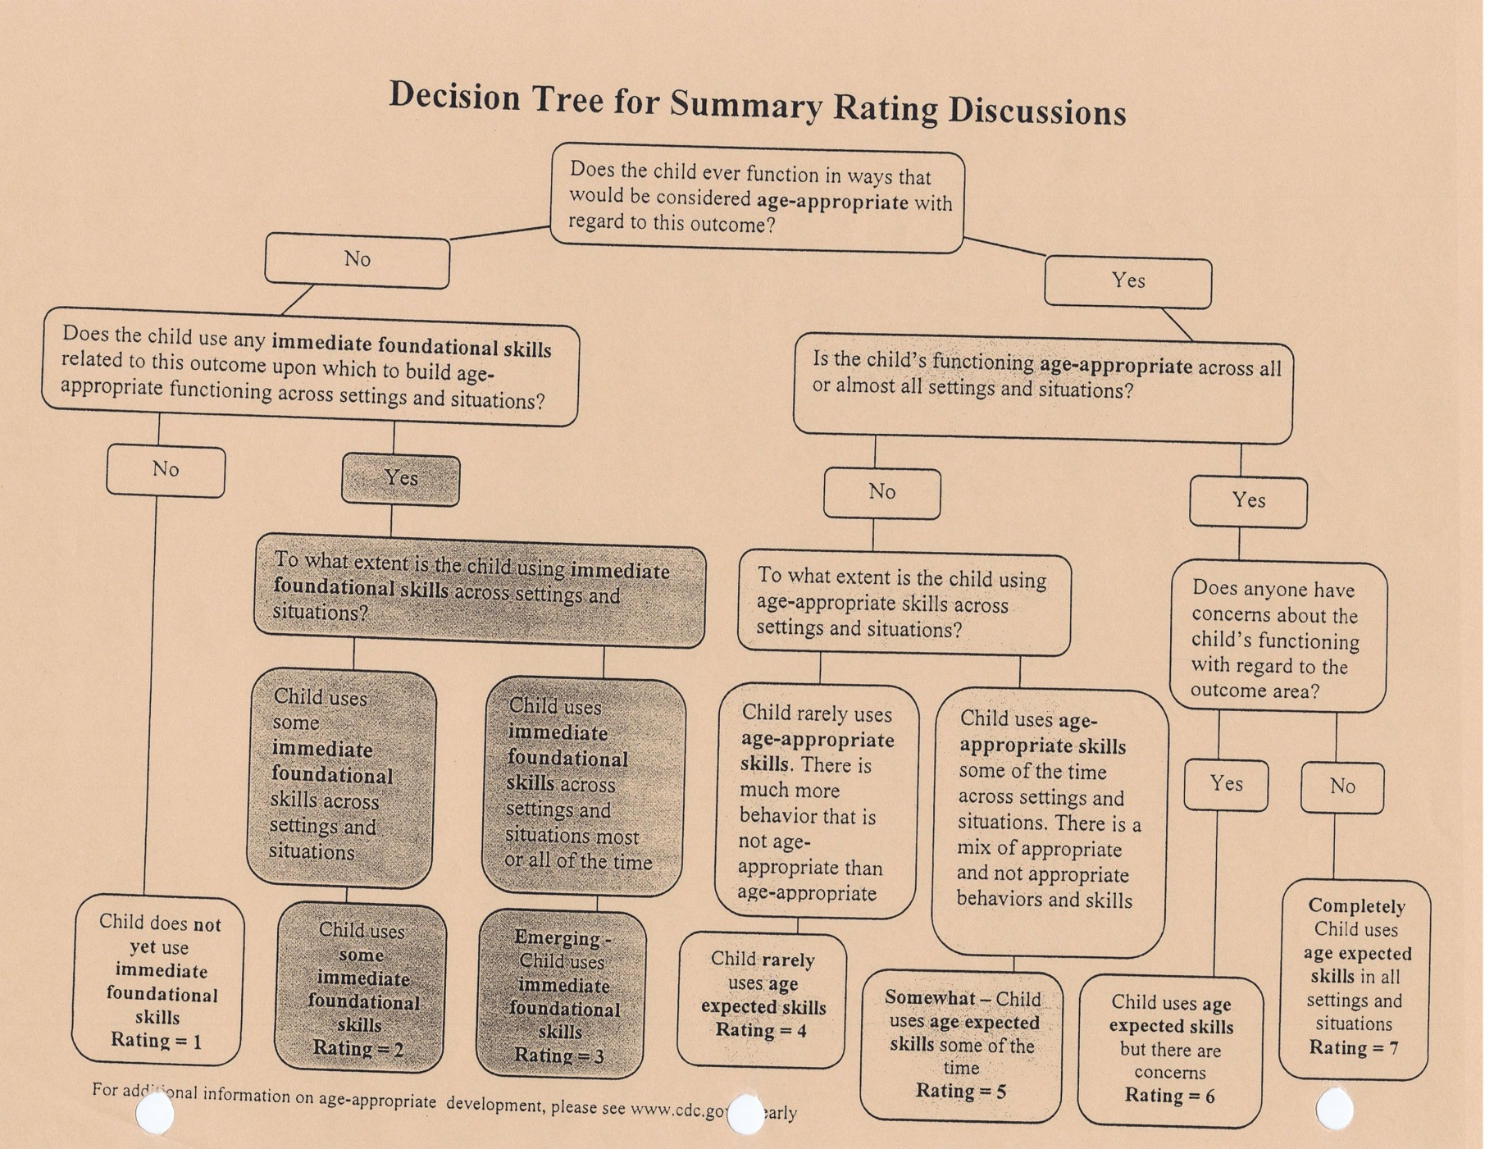

72
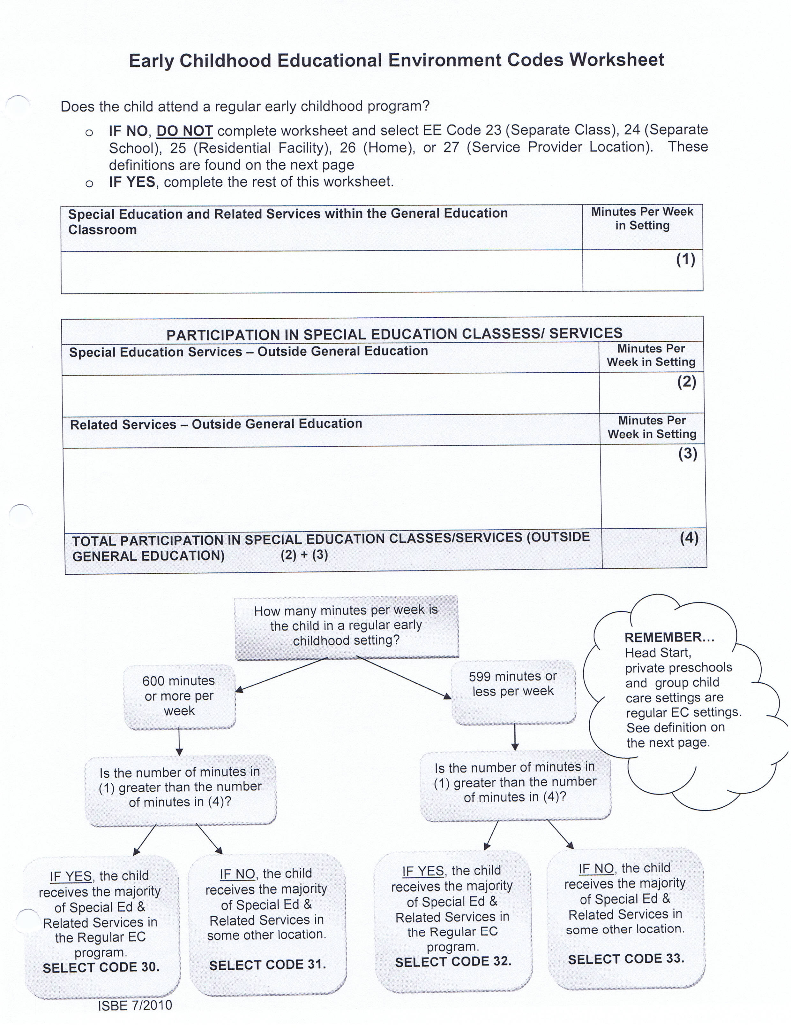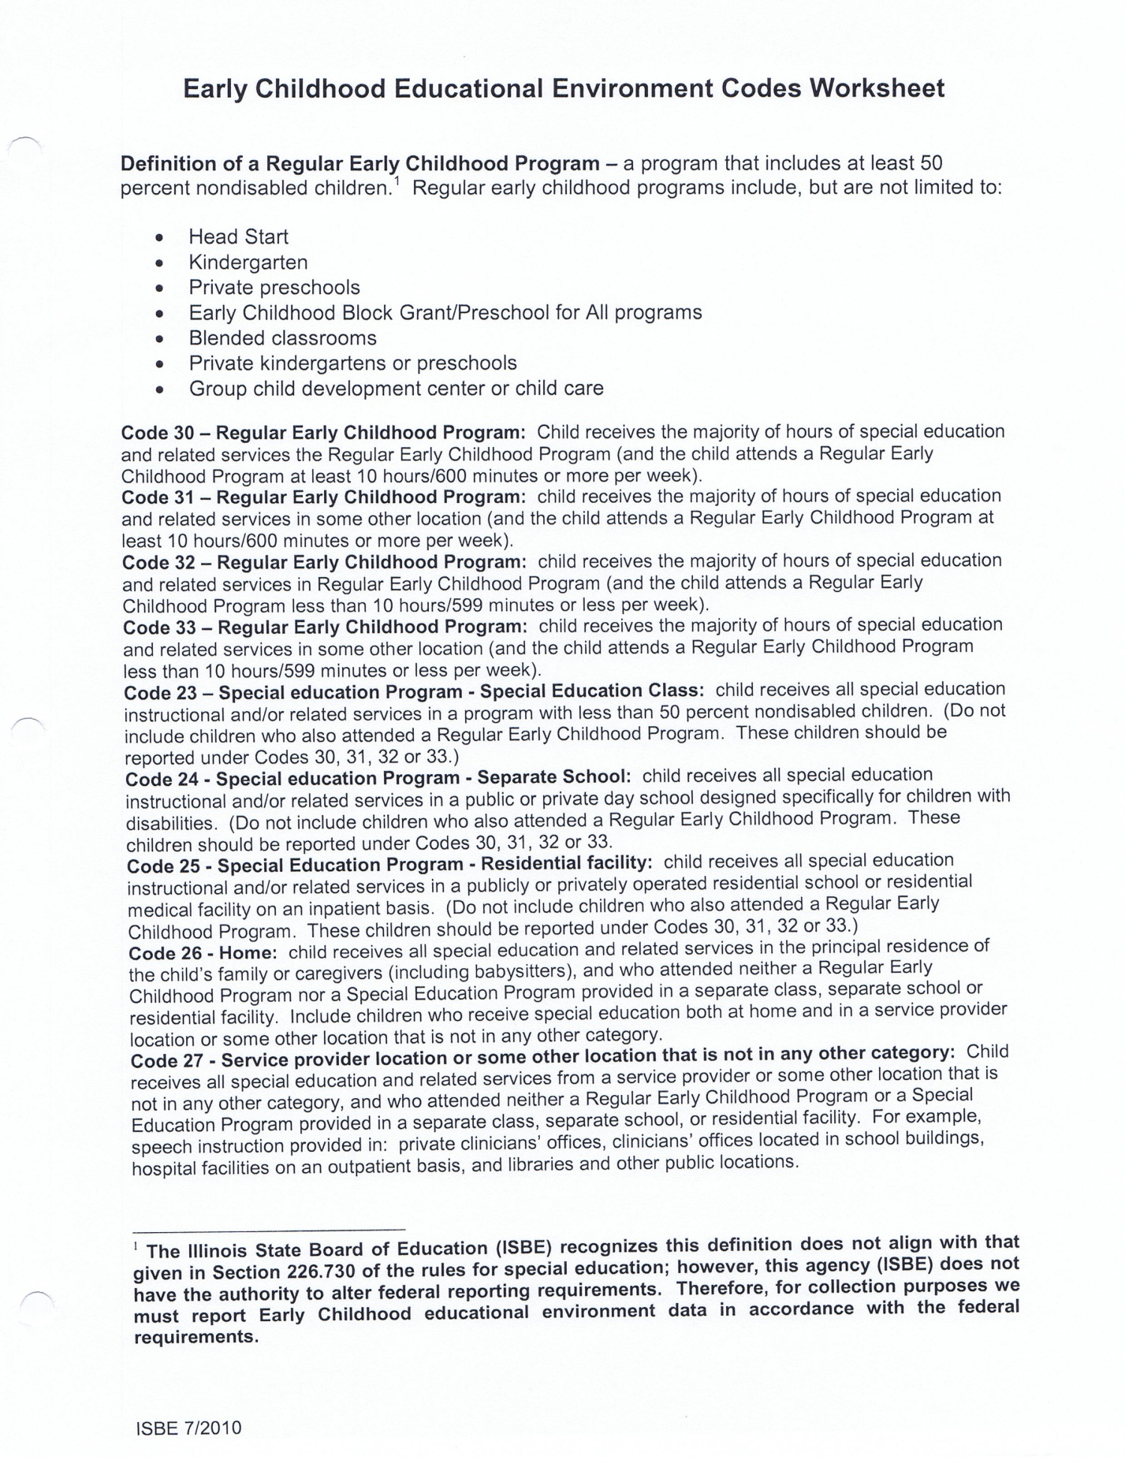
74

EE Codes
Determining Educational Environment Codes

On the “Educational Services and Placement” form of the IEP, you will need to calculate the EE Code. You will calculate this on either the left side or the right side, depending on the student’s age.

The Left Side: this is for students who are in an Early Childhood Program (see the top of page 74 where it lists these programs) AND are not yet age 6.
      - Select Location.
      - Check the box for Early Childhood Program.
      - Set the minutes (these will come down from what you have entered up above under special education and related services).
The Right Side: this is for students who are age 6 and up.
- Select Location.
- Set the minutes (these will come down from what you have entered up above under special education and related services).
For Walk-In Speech/Language-Only Students: do the following:
- Select Location.
- Check the box for Early Childhood Program if the student is under the age of 6.
- Enter the number of “Minutes spent in Regular Early Childhood Program” IF they attend a Community Preschool/Daycare, or a Church Preschool (Not a home daycare).
- Enter the number of speech minutes.
- If the child is at home with parent or at a home daycare and just walks in for speech, enter the number of speech minutes on the “Regular Early Childhood Program” line.
- DO NOT “Set Minutes.”
- Click out of that, and your %s will appear

75

PROCEDURAL SAFEGUARDS: Purpose and Use

Purpose:
The Explanation of Procedural Safeguards summarizes and notifies the parent/guardian regarding the procedural safeguards to which they and their child are entitled.

Form Use:

Written notification of the procedural safeguards available to the parent(s) of a child with a disability shall be given to the parent(s) one time per school year, and:
- An initial request for an evaluation or reevaluation;
- Upon receipt of the first written State complaint;
- Upon receipt of the first due process complaint in a school year;
- Upon a disciplinary removal that constitutes a change in placement;
- Upon parental request;

For private/parochial students: the Procedural Safeguards are distributed to the parents during the child-find portion only. (Referral and Evaluation process only).

Location: These are found in K.I.D.S. in the Notice and Consent section.

81

K.I.D.S. SOFTWARE: HOW TO ACCESS

K.I.D.S. stands for “Kids Individualized Data System”
All IEPs are created using this software.
Two Ways to Access:
- Filemaker Pro11:
- SLPs MUST have this program installed on their school computer(ask your technology person if you don’t have it).
- You must use Filemaker Pro11 in order to add a new student.
- To enter: click on the Filemaker Pro11 icon on your computer.
- Click on: Remote.
- Numbers will pop up, click on (216.124.153.5)
- Click on: IEP
- Click on: Open
- Enter: user name and password which was provided by TCSEA. DO NOT share your password with other special education staff! Your log-in information allows you to: enter a new student; and also archive your S/L-only files. Also DO NOT complete these tasks for other special education staff! They can call Tri-County for assistance.

- Internet:
- www.tcsea.org
- Scroll down and look on the left side.
- Click on: Tri-County Use Only.
- Enter: User name and password assigned to you by TCSEA.
- Use the red X to exit out of a page.
- For printing: preview and print each page individually.
- Refresh periodically, using the forward and back buttons (or will lose information).

84

LRE Codes on the IEP
The LRE codes are as follows:
01 Inside general education classroom 80% or more of the day
02 Inside general education classroom 40-79% of the day
03 Inside general education classroom less than 40% of the day
04 Spec. Ed. 100% in separate public school
05 Spec. Ed. 100% public & residential by resident district
06 Philip J. Rock Center & School (fund code H)
07 Full time Special Education in County Jail
08 Private Day School or Out of State Public Day School
09 Private Residential Facility, In-State
10 Private Residential Facility, Out-of State
11 Home Residential Facility, Out-of-State
12 Hospital Instructional Program
13 Illinois School for the Deaf
14 Illinois School for the Visually Impaired
15 Illinois Center for Rehabilitation & Education
16 Department of Human Services
20 Inside Regular Pre-School Program at least 80% of the time
21 Inside Regular Pre-School Program 40-79% of the time
22 Inside Regular Pre-School Program less than 40% of the time
23 ECSE Class – Separate Class
24 ECSE School – Separate School
25 ECSE – Residential Facility
26 ECSE – Home (Speech/Language delivered in home)
27 ECSE – Service Provider Location (Speech/Language only Drop-In)
28 Parentally placed in Non-Public Schools and Home-School
Additional information about the LRE codes:
      - For students ages 6-22, use the following codes: 01, 02, 03, 04, 05, 06, 07, 08, 09, 10, 11, 12, 13, 14, 15, 16,
28
      - For students ages 3-6, use the following codes: 20, 21, 22, 23, 24, 25, 26, 27
      - For Private/Parochial Students ages 3-6, use code: 27. Ages 6-21, use code: 28.
      - Don’t use 23 or 27 for ECE or drop-in speech services if you KNOW the student is attending some other type of regular preschool any other part of
the week. You should use : 30, 31, 32, 33

85

Excusal Form: Purpose and Use for SLPs

The Basics of a S/L only IEP meeting:
- Invite parents, one general education teacher.
- Invite principal/or get permission to serve as Local Educational Agency (LEA) representative.
- If the general ed. teacher or principal can’t attend, find an appropriate substitute. *Indicate the role of each person on the notification form.
- Hold the meeting. **All attendees should sign and indicate which role they are serving i.e. LEA rep; general education teacher, etc.
- IF you can’t find an appropriate substitute, you will need to utilize the excusal form: Parent agreement OR Informed Consent (see below for detail on how to use).
- Location of excusal form: K.I.D.S. Software-- Notice & Consent Forms-- Excusal of an IEP team member.

Excusal Form: Purpose

- This form is intended to be an infrequently used option.
- The form’s purpose is to provide IEP teams with the flexibility to schedule an IEP meeting with a parent at the parent’s earliest convenience even when the schedules of one or more other required IEP team members will not allow for attendance.
- Excusal is the procedure for obtaining either parent agreement or informed parental consent to allow a required member (or appropriate substitute) of a child’s IEP team to be absent from an IEP meeting.

86

IEP Amendment Form: Purpose and Use
Purpose:
The Amendment form notifies the parent/guardian of minor changes that have been made to the IEP when the school district and the parent/guardian agree not to reconvene the IEP meeting for the purposes of making minor changes to a student’s IEP. A written document to amend the student’s current IEP must be completed.
Form Use:
The amendment form is used to provide written documentation of minor IEP changes that do not significantly change services and/or do not change placement.
**The SLP may use this form to make changes such as the following:
- Minor decrease/increase in number of weekly service delivery minutes
- Minor change in service delivery models
- Addition of objectives under a S/L goal

Additional Instructions:
- This form should be used only for minor IEP changes that do not change a student’s placement.
- The district should communicate with the parent/guardian about the minor changes to the IEP. The date of contact, district personnel and title, and the mode of communication (meet in person; phone; e-mail; fax) should be documented on the form.
- The actual changes and an explanation of the changes should be documented. The district should ensure that the written documentation of the minor changes reflects the communication that took place with the parent/guardian.
- Complete the FACTS sheet in K.I.D.S. and fill in the date of the meeting under “Date Completed.” DO NOT change the “Begin Date.” That stays the same throughout the school year.
- The name, title, and phone number of a district contact person should be included.
- This form must be placed in files designated by the school district.
- If this is an IEP file that is kept at TCSEA, then this form must be sent to a Tri-County office along with a current copy of the IEP.
- A copy of the student’s current IEP, along with this form should be given to the parent/guardian.

87

Termination/Exit form: Use

When you terminate a S/L only student:
- FILL OUT termination form with code, exit date and other information.
- (If a S/L-only student moves out of your district over the summer, the end date will be the last day of school the previous spring)
- K.I.D.S Software: Click on: Student Data
- Click on: Student Information
- Enter End Date
- Change Flag to: Not Eligible (if no longer eligible) or Inactive (if graduated or moved out of Tri-County schools).
- Click on SET FILE
- E-mail Laurie harpenaul@tcsea.org and tell her that student’s name, DOB has been dismissed
- Class Enrollment Reports: You might have students on your class enrollment report that you have terminated. They will have an “end date.” They will remain there until moved to either Inactive or Not Eligible.

- When you terminate a secondary or related S/L service:

  - FILL OUT termination form with code, exit date and other information.
  - Always use code 20 when dismissing from S/L, but continuing with other services.
  - On the line below the code line, choose an option.
  - Always use code 20 when moving a child from an IEP to a service plan, or vice-versa.
  - On the line below the code line, type in the explanation.
  - If possible, place your termination form directly under the FACTS sheet to be sent to Tri-County.
  - E-mail Laurie harpenaul@tcsea.org and tell her that student’s name, DOB has been dismissed.

88

FACTS sheet: Purpose and Use

Purpose:

The purpose of the FACTS sheet is to ensure accurate and updated reporting to the state.

Use:

The FACTS sheet is used only at IEP meetings.

For Speech/Language-Only IEPs, the SLP needs to:
1. Fill in the "Date Completed" with the date the meeting was held.
2. Answer the "Foster Student?" question with either a "y" or "n."
3. Do NOT change the "Begin date." That stays the same throughout the school year.
4. The FACTS sheet does NOT need to be printed as long as it is completed in Filemaker.
5. Email Laurie harpenaul@tcsea.org at TCSEA and give her the student's name and DOB.

NOTE: I have found that printing FACTS sheets for my S/L-only students is very helpful when I am completing the turn-around information for Laurie multiple times each year. You can easily get the % of special education time right off of the FACTS sheet.

89

FILEMAKER PRO 11
SLP Responsibilities for S/L-only students
SLPs are responsible for creating and maintaining accurate files for S/L-only students in Filemaker Pro11.
1. Procedure for entering a new student:
Utilize any drop down menus
● Go to: Main menu
● Click on: Student Data
● Click on: Student Information
● Click on: New Record
● Enter the information as indicated below

For Initial Input of Student:
NOTE: This section applies also to Private/Parochial/Home Schooled Students.
● Name (Last, First, and Middle name)
● Birthdate (mm/dd/yy)
● Ethnicity
● Language
● Grade (current grade)
● Parent Consent for Initial Evaluation: (the date initial signed consent to evaluate
was received. THIS WILL NEVER CHANGE!)
● Parent Consent for Reevaluation: (the date signed consent to re-evaluate was
received.)
● Private/Parochial/Home Schooled: Check Y (if applicable)
● District/School – In both Parent Information & Placement Information

91

● Parent Name & Address
● Foster Yes/No
● Active Flag – Pre
● Case Manager (SLP) use the drop down menu. DO NOT TYPE in your name.
● SET FILE (right side of screen)
NOTE: The SET FILE is extremely important! If you forget this step, the student
entered will not be read by the program.
NOTE: For Private/Parochial and Home-Schooled Students: in the “placement” section, enter the district in which the private/parochial school is located.

II. Procedure for locating a student already in the system:
Utilize drop down menus
● Go to: main menu
- Click on: enter find
● Type in student name
● Click on: perform find
● Click on: student data
● Click on: student information
Following an EDC, check that the following are correct on the student
information page in Filemaker Pro11:
NOTE: This section applies also to Private/Parochial/Home-Schooled Students.
- EDC Date
- Exceptional Characteristic – Eligibility Code (EC 1) (put S/L) (use pull-down menu)
- Change Active Flag – Active or Not Eligible
- Case Manager (use pull down menu)
- SET FILE (right side of screen)

92

Following an IEP:
- Case Manager
- Grade (look at IEP begin date: what grade is the student in?)
- Begin Date
- District/School Information
e. Annual review date
f. Related services (very unusual for a S/L only student) *PLEASE e-mail Joyce
and ask for help if this occurs.
NOTE: For eligible walk-in speech/language-only IEP students, please complete the ISBE SIS request form, and turn in to the district SIS entry person.

Note: After the record is complete, Archive the File.

Following a Student Service Plan Meeting:
- Case Manager
- Grade
- Begin Date
- District/School Information
NOTE: Use the “Student Service Plan” form in the “Supplemental Forms” section of K.I.D.S. Send an email to Laurie at Harpenaul@tcsea.org and give her the student’s name and DOB.

NOTE: After the record is complete, Archive the File.

Following a termination:
NOTE: This section applies also to Private/Parochial/Home Schooled Students.
- Enter end date
- change Active flag to Inactive( if the student graduated, or moved out of
Tri-County schools),
- change Active flag to Not Eligible (if dismissed from S/L only services.)
- SET FILE (right side of screen)

NOTE: If a speech-language only student moves out of your district over the summer,
enter the end date as the last day of school the previous spring.
93

S/L-only IEP Students Moving In or Out of District
If a Speech/Language-only IEP student moves OUT of the district:
1. Complete a Termination/Exit form.
2. Put the form in the student's file.
3. Email Laurie at Harpenaul@tcsea.org and give her the student's name and tell her
that it is a termination.
4. Go into Filemaker and the Student Information page and enter an "end date" and
change the flag to "inactive."
5. IF the student moved over the summer, then the exit date is the last day of student
attendance from the spring.

If a Speech/Language-only IEP student moves IN with an IEP: OPTIONS:
1. Accept the IEP as written:
a. You will need to begin a new record for this student and enter the IEP information
into Filemaker if student is from outside of Tri-County schools.
IF the student is from another Tri-County school, he/she will be in Filemaker.
You'll need to change the district, school, case-manager and address on the
Student Information page.
b. Print a new IEP. Distribute appropriately.
c. Email Laurie at Harpenaul@tcsea.org. Give her the student's name, tell her
that he/she is a move-in student, and give her the S/L services start date.
2. Make Minor Changes to IEP:
a. You will need to begin a new record for this student and enter the IEP information
into Filemaker if student is from outside of Tri-County schools.
IF the student is from another Tri-County school, he/she will be in Filemaker.
You'll need to change the district, school, case-manager and address on the
Student Information page.
b. Contact parent.
c. Fill out "Notification of IEP Amendment" indicating the changes.
d. Enter the IEP information into Filemaker to represent the new IEP.
e. Print a new IEP. Distribute appropriately.
f. Send the new IEP, including the Amendment form to the parent.
g. Email Laurie at Harpenaul@tcsea.org. Give her the student's name,
tell her that he/she is a move-in student and give her the S/L services start date.
3. Make significant changes to the IEP:
a. Convene the IEP meeting with 10-day notification.
b. Follow instructions above (2abdeg).
****An IEP must be developed with the first 30 school days of the student's
attendance at the school.****
93A
SLPs send to Laurie at Tri-County
The following information needs to be sent to Laurie Harpenau at TCSEA
All of Laurie’s reporting is directly tied to reimbursement for districts:
- Following a Speech/Language-Only IEP or Annual Review:
- Complete the FACTS sheet in K.I.D.S.
- Begin Date: This is the date school started for the current year. DON’T
change this date during the school year.
- Foster: Answer Yes or No.
- Date Completed: This is the date the meeting was held.
- Email Laurie at Harpenaul@tcsea.org and give her the student’s name and DOB.
- Following a Termination/Exit of a Speech/Language-Only Student:
- Fill out the termination form.
- End date: the date the student stopped receiving S/L services, which is the only type of special ed services he/she is receiving.
- Code: Use the drop-down menu and choose the appropriate code.
- Email Laurie at Harpenaul@tcsea.org and give her the student’s name and DOB.
- Following a Termination/Exit of a S/L as a Related or Secondary when other special education services will continue:
- Fill out the termination form.
- End date: the date the student stopped receiving S/L services.
- Code: This will always be code 20 IF the student is being dismissed from S/L services, but will continue receiving other special education services.
- Line under the Code line: Use the drop-down menu and choose the appropriate explanation.
- Email Laurie at Harpenaul@tcsea.org and give her the student’s name and DOB.
- If a student goes from IEP to Service Plan:
- Complete the Student Service Plan form.
- E-mail Laurie at Harpenaul@tcsea.org and give her the student’s name and DOB, and explain that he/she is going from IEP to Service Plan.

94

PROGRESS REPORTS

The SLP is responsible for writing progress reports that:
- provide information for each objective;
- are shared with each parent;
- Follow a schedule that is consistent with that determined on the IEP.

Using K.I.D.S. Software:
- Access the K.I.D.S. software.
- Click on: Enter Find
- Type in student’s name
- Click on: Perform Find
- Click on: One of the boxes under Go to Archive Files
- Use the Records Down key to nudge down to the record with the appropriate conference date.
- Click on: Eligibility/IEP Program
- Click on: Goals and Objectives. Locate a goal with SLP as implementer. Under each short term objective are lines 1, 2, 3 and 4.
  - Each line represents one quarter for the duration of that IEP.
  - Fill in “Date Reviewed” with the end of that Quarter.
  - Fill in “Extent of Progress” with data and information.
- Repeat for each goal with SLP as implementer.
- Click on: Menu
- Click on: Print Menu
- Provide a copy to the parents.
NOTE: It is required that a copy of the progress report be placed in the student’s temporary file.
For S/L as a Secondary or Related Service: In many schools, the SLP reports progress on objectives, and tells the case manager that she is done. Then the case manager prints and distributes the progress reports. Find out what process the special education staff follow at your school.

95

ANNUAL REVIEWS (IEP)
Speech and Language Only Cases
(SLP as case manager)
An annual review is an IEP meeting held at the end of the IEP’s duration.
IEPs are now written for year-round services. ( i.e. November-November).These involve two grade-levels for the student in most cases.
- Notification: Refer to Page 21 of this manual for instructions on scheduling
and notifying participants of an IEP Annual review meeting.
- Prior to the Annual Review:
- Gather information from teacher(s) regarding the impact of the S/L impairment in the classroom. Can use: Teacher/Parent Interviews: Language, Speech Sound Production and Use, Fluency, Voice.
- Gather information from the parents.
- Update progress on IEP goals and objectives.
- Gather information from the student. Can use Child Interview Checklist.
- Complete the new IEP document using the K.I.D.S. software.
- At the IEP Annual Review meeting:
- All participants should sign NAME and ROLE on the Conference Summary Report.
- Report on the current IEP goals and progress made toward those goals and objectives.
- Ask for parent input.
- Ask for input from the classroom teacher.
- Present the information on the new IEP document with input from team members.
- Plan to edit the document during discussion. Use K.I.D.S. to make changes.
NOTE: The SLP should reference the “Eligibility Criteria/Matrix” for assistance in determining the number of service minutes per week, and the service delivery models.
- Finalize the IEP document, and review any changes with the parent.
- Complete the FACTS sheet.
- Print the IEP.
- The parents receive a copy of the IEP.
- A copy of the IEP is placed in files designated by the school district.

96

K.I.D.S. Forms:
Notification of Conference Report
Explanation of Procedural Safeguards
Conference Summary Report
Present Levels of Academic Achievement and Functional Performance
Goals and Objectives/Benchmarks
Educational Accommodations and Supports
Assessment
IAA Participation Guidelines
Educational Services and Placement
FACTS Tracking Sheet
Notification of Conference Recommendations

97

Birth to Age 5 years Speech/Language Developmental Milestones

Age Receptive Expressive Phonology Pragmatics
0-1 mo. □ sticks out tongue □ reflective cry N/A N/A
□ turns head toward sound □ differentiated cries
□ reacts to sounds
□ discriminates caregiver’s face
from unfamiliar face

1-2 mo. □ looks intently at speaker □ throaty noises N/A N/A □ vowel-like sounds
□ changes in pitch to
signal discomfort

2-3 mo. □ reacts positively to human □ babbling, cooing, gurgling N/A N/A
voice □ imitates adult sounds
□ discriminates caregiver’s □ repeats sounds for physical
voice pleasure

3-4 mo. □ cause/effect emerges □ smiles, laughs N/A N/A
□ recognizes mother’s voice □ responds vocally/bodily to
intonation changes
□ uses suckling pattern if
spoon is introduced
□ makes responsive sound if
spoken to
□ initiates vocalizations by
Babbling

101

Age Receptive Expressive Phonology Pragmatics
4-5 mo. □ turns head at sound of voice □ laughs, vowel sounds N/A N/A
□ follows mother’s visual focus □ sucking pattern more
□ recognizes stimuli that vary in frequent than suckling
pattern
□ localizes sounds □ laughs aloud in response N/A N/A
to others
□ self-initiates sound play
□ prelinguistic vocalization
(vowels, raspberries)

5-6 mo. □ recognizes familiar melodies □ solitary vocal play N/A N/A
□ coos, babbles, high squeal
□ indicates needs by crying
□ cries @ angry voice
□ laughs @ pleasant voice

6-7 mo. □ listens to own voice □ several well defined syllables N/A N/A
□ knows when to smile □ VC syllables
□ imitates specific sounds
□ vocalizes to music
□ signals end of turn by gaze
□ directs sounds & gestures to
objects

(ASHA) – “How Does Your Child Hear and Talk?”;
(St. John’s Hospital Speech-Language Therapy) “Developmental Continuity Clinic
Evaluation Report”; (Caroline Bowen Ph.D. SLP) “Ages & Stages Developmental
Milestones”; (Child Development Institute) “Language Development In Children”

102

Age Receptive Expressive Phonology Pragmatics
7-8 mo □ understands 1st words (no-no)
□ Pays attn. to family □ vowel sounds in a series N/A N/A
member voices □ vocalizes satisfaction re: object
□ attend to pictures □ vocalizes emotional state
□ searches for hidden objects □ reaches for self in mirror
□ recognizes name □ deep sounds/grunts

8-9 mo. □ alert to environmental □ vocalizes to familiar items N/A N/A
stimuli □ shouts/vocalizes to gain attn.
□ explores toys orally
□ vocalizes 2 syllable combinations
(reduplicated or varigated)

9-12 mo. □ looks for a named object □ imitates non-speech sounds N/A □ performs for
(cars, animals) social attn.
□ gives item when requested □ indicates desire for
□ identifies 2 body parts on self □ points to desired object change in activities □ approximates single words □ vocalizes to call &
□ waves “hi” and “bye” respond to others
□ plays social games (peek-a-boo)

12-15mo. □ understands “no” MLU – 1-2 words CV, CVCV □ initiates turn taking Emerging CVC
□ follows 1 step commands □ initiates other
children
□ demonstrates functional use
of objects □ vocalizes more in
play
□ uses more words in
□ points to action words in turn taking
pictures
□ identifies 3 body parts on self
103

Age Receptive Expressive Phonology Pragmatics
15-18 mo. □ understands 50 words □ MLU - 2 words □ plays away from
familiar people
□ identifies 6 body parts □ names 5-7 familiar items □ uses words to protest
□ retreats to caregiver
for reassurance

18-24 mo. □ points to 2 pictures/ □ MLU 2-3 words □ produces □ turn taking during
common objects □ vocabulary of 10 words T, D, N, H, conversation
□ follows 1 step auditory □ uses 1 pronoun P, B, M, W
direction □ agent + action + object
emerging

24-36 mo. □ understands concept of “I” □ MLU 3 words □ emerging k,g □ emerging proximity
□ understands function of □ uses negation (no, not, d, ng, f rules
objects don’t) □ produces final □ demonstrates
□ understands simple attributes □ uses regular plurals consonants parallel play,
□ understands prepositional □ uses possessive markers emerging inter- phrases □ uses present tense (-ing, -s) active play
□ understands prepositions □ repeats 2 unrelated words
(on, in, under) □ states 1st & last name
□ understands subjective □ asks & answers yes/no
pronouns (he, she, it) questions
□ answers “who”, “what”,
“where” questions

104

Age Receptive Expressive Phonology Pragmatics
36-48mo. □ understands prepositions □ MLU: 3 to 4 words □ emerging r, L. □ exhibits proximity
(over, behind) □ names 4 colors s, y rules,
□ groups objects into
categories □ tells about immediate □ consonant □ initiates context
(toys, animals, clothes, experiences blends emerging relevant topics
food)
□ states function of objects □ states feelings &
□ provides logical answers to needs
questions (i.e. what do you □ interactive play
do when you’re sleepy?) □ recognizes distress
□ answers “when” questions of a peer
□ completes simple analogies
□ refers to self with name, age,
gender
□ uses articles,
□ regular past tense,
□ subjective pronouns
(“we”, “they”),
□ objective pronouns
(“him”, “her”, “they”),
□ copula (is, are)
□ emerging irregular
past tense

105

Age Receptive Expressive Phonology Pragmatics
48-60 mo. □ understands complex □ MLU: 4 to 5 words □ emerging □ use simple directions j,sh,v,z , strategies to
□ understands time concepts states spatial concepts: voice & voice-less resolve
(next to, beside, behind, TH problems
in back of, in front of □ conversation
for 3 turns
□ names 3 items in a category □ produces □ states category label when consonant
given items in a category blends □ initiates
conversation
at an appro-
priate time
□ uses irregular past tense, □ possessive pronouns (“his”,
“hers”, “its”, “their”, “theirs”)
□ uses future tense and
prepositions
□ answers “why” questions

(ASHA) – “How Does Your Child Hear and Talk?”;
(St. John’s Hospital Speech-Language Therapy) “Developmental Continuity Clinic
Evaluation Report”; (Caroline Bowen Ph.D. SLP) “Ages & Stages Developmental
Milestones”; (Child Development Institute) “Language Development In Children”

106

TCSEA: Speech/Language Lending Library: Evaluation Instruments
Best practice dictates that students are evaluated using current evaluation instruments. This necessitates replacement of test materials as they become obsolete.
It is suggested that the SLP and District Administrators determine a schedule for keeping the Speech/Language Evaluation instruments current in each district, i.e. replace one evaluation instrument each school year.
Tri-County has the following evaluation instruments in the S/L Lending Library:
- ABLLS-R Protocol
- ABLLS-R (Assessment of Basic Language and Learning Skills-R)
- Ages & Stages Questionnaires-3rd edition
- ALST (Adolescent Language Screening Test)
- Boone Voice Program for Children – Complete Program
- CARS (Childhood Autism Rating Scale)
- CASL (Comprehensive Assessment of Spoken Language)
- CELF-4 (Clinical Evaluation of Language Fundamentals – 4th edition)
- CELF-5 (Clinical Evaluation of Language Fundamentals – 5th edition)
- CELF-4 Screening Test
- CELF-Preschool-2
- DASH-2 (Developmental Assessment for Individuals with Severe
Disabilities-2)
- Differential Screening Test for Processing
- Early Functional Communication Profile
- Functional Communication Profile – R
- GARS (The Gilliam Autism Rating Scale)
- GFTA-2 (Goldman-Fristoes Test of Articulation-2)
- KSPT (Kaufman Speech Praxis Test for Children)
- LSAT-3 (Language Sampling, Analysis and Training-3rd edition)
- PLS-5 Screening Test
- PLSI (Pragmatic Language Skills Inventory)
- Quick Screener (articulation)- Caroline Bowen
- Social Language Development Test-Adolescents
- SPELT-3 (Structured Photographic Expressive Language Test)
- SSI-4 (Stuttering Severity Instrument-4)
- TOPL-2 (Test of Pragmatic Language-2)
- Test of Social Language Development Test-Elementary

110

Tri-County has the following materials in the S/L Lending Library:
- “Analyzing the Communication Environment: An Inventory of Ways to
Encourage Communication in Functional Activities”
- “Augmentative Communication Assessment Resource”
- “Augmentative Communication: Intervention Resource”
- Boone Voice Program for Children-Complete Program
- “Bringing Words to Life: Robust Vocabulary Instruction
- “Communication Lab Profile: Assessing your Students’ Classroom Communication”
- “Communication Lab – 1 A Classroom Communication Profile”
- “Communication Lab – 2 More Classroom Lessons for Communication”
- “Communication Skills in Children with Down Syndrome: A Guide for Parents”
- “Easy Does it for Apraxia and Motor Planning” (Therapy Manual)
- “Easy Does it for Apraxia and Motor Planning” (Materials book)
- “Engineering the Preschool Environment for Interactive, Symbolic Communication”
- “Engineering Training Environments for Interactive Augmentative Communication (For Adolescents and Adults)”
- Entire World of R: Curriculum book
- Entire World of R: Say and Sequence cards
- Every day interactions – book and DVD
- Finding the Main idea – reading level 4
- Fifty (50) Great Activities for Children Who Stutter
- Focus on Fluency – Tool kit
- “Functional Vocabulary for Adolescents and Adults” (Home-Community-Work-Leisure) with CD
- Incorporating Social Goals in the classroom
- “Inside Out: What Makes a Person with Social Cognitive Deficits Tick?”
- Kaufman Speech Praxis Treatment Kit 1 for Children
- Kaufman Speech Praxis Workout Book
- Kaufman Treatment Kit (Advanced Level)
- Play-Based Speech for Children with Hearing impairments
- Power Cards
- RtI Sourcebook
- Social Language for Teens
- “Socially Curious and Curiously Social”
- “Teach Me Language”
- “Teaching Language to Children with Autism or Other Developmental Disabilities”

111

- “The Source for Down Syndrome”
- “The Source on Fluency”
- “Treatment Protocols in Communicative Disorders: Targets & Strategies”
- “Using Familiar Routines in Language Assessment and Intervention”
- “Visualizing and Verbalizing for Language Comprehension & Thinking” (Kit)
- “Visual Strategies for Improving Communication: Practical Supports for School and Home”
- “Worksheets! for Teaching Social Thinking and Related Skills”
- “You Are a Social Detective”
- “You Make the Difference”

112

Private/Parochial and Home-Schooled Students – Guidelines

SLP Responsibilities to students attending private/parochial schools, and home-schooled students within the district’s boundaries:
- For children ages 3 years - 6 years, follow the same procedures as with public school students. (Screen/evaluate/EDC/IEP/3-year re-evaluation/Termination.)

EXCEPTIONS:
  - If a child attends a daycare where there is a curriculum for school-aged students, then that daycare constitutes a “private” school. In cases like this, the student would receive S/L services on a Service plan, NOT an IEP.
  - If the parents have a curriculum for older children and your student is in this parent’s care, then this would constitute a “home-school” and the student would receive S/L services on a Service plan, NOT an IEP.

- For children ages 6 years and up, follow these guidelines:
- Keep the school administrator informed of any home-schooled/
private/parochial students currently on your caseload.
- Inform the school administrator any time you receive a referral for an
evaluation for a home-schooled/private/parochial student.
- Screen home-schooled/private/parochial students following a parent/teacher/outside agency referral.

- Follow the same procedures and utilize the same paperwork during the identification process as with public school students. **Parent Rights are distributed to parents during the identification process only.** When you initially enter the student in the “Student Information” page of K.I.D.S., check “Y” next to “Private/Parochial/Home-schooled.”

- If S/L eligibility is determined, ask your building administrator about the existence of a “School Service Plan, and if S/L services can be provided. If so, a Student Service Plan should be developed. The School Service Plan will provide guidelines for determining weekly service minutes. The building administrator may determine that S/L services cannot be provided for a particular student until the following school year due to proportionate share funding.
- Use the Student Service Plan form on page 116 of this manual.
- The Student Service Plan is located in K.I.D.S. in the “Supplemental Forms” section, menu 3.
- Once the Student Service Plan form has been completed, email Laurie at Harpenaul@tcsea.org and tell her you just wrote a student service plan for: student name/DOB.
- Once the Student Service Plan is written for a student, follow the same procedures and utilize the same paperwork for 3-year re-evaluations and terminations as with public school/IEP students.
115

Private-Parochial/Home-Schooled Student Service Plan
____________School year

- This Student Service Plan is based on the School Service Plan agreement made
by the _______________________________________________________public school district and the
____________________________________________________________private-parochial school on the
following date: _____________________________.
II. Student Information:
Name: ______ Birthdate: _________________________________
Ethnicity: ______________________________Grade: ___________________ Gender: _______________
Address: _____________________________________________________________________________________
Parent Names/Address: ___________________________________________________________________
_________________________________________________________
Phone #’s: _____________________ ______________________ ______________________
Public School District in which child resides: ___________________________________________
School child would attend if at a public school: __________________________________________
Disability(ies): ________________________________ __________________________________
Date of most recent eligibility conference: ____________________________
Case Manager: __________________________________________________
III. Fund Code: ____________________

IV. LRE Code: ________________

IV. Services to be provided:
Begin date Service Amount Frequency_______
_______________________________________________________________
_______________________________________________________________
_______________________________________________________________
V. Signatures: Signing this document verifies participation in the service plan
meeting for this student. Include name, title and date.
___________________________________________________________________________________
__________________________________________________________________________________
___________________________________________________________________________________

Indicator 11 Information

- Tri-County, along with the 16 member districts has a 60-school day timeline for completing evaluations. We must report information for initial evaluations to the state.
- This applies to potential IEP students and potential Student Service Plan students!
- What is an initial evaluation? It is the first time a particular child is evaluated within the public school system for any type of special education.
- SLPs are responsible for meeting the 60-school day timeline for speech/language only evaluations.
- There can be no more than 60-school days between the date of signed consent to evaluate, and the EDC date.
- For evaluations that take place over the summer, the EDC must be held before or on the first half-day of student attendance for the new school year in order to be in compliance.
- Each fall, Tri-County’s SLP Supervisor will send all SLPs the Indicator 11 Instruction sheet, the reporting spreadsheet, and the chart for calculating 60-school days for that school year.
- SLPs are responsible for tracking the initial speech/language only evaluations throughout the school year.
- In the spring, Tri-County’s SLP Supervisor will ask all SLPs to report Indicator 11 information by a specified deadline; which is typically the middle of May.
Spreadsheet Instructions:
Last, First Name
Date of Birth
Initial Date of Signed Consent to Evaluate
EDC Date
Eligible or Ineligible If Eligible and receiving services, no code is needed.
If Eligible and not receiving services, choose a code below.
If Ineligible, choose a code from below:
Codes:
01 Student is not eligible
02 Student is eligible; parent refuses services
03 Student is eligible; no program available
04 Student is eligible; pending placement. (i.e. the child is eligible, but the IEP doesn't start until the next school year)
05 Student is not of eligible age: 2 years old

District
School

120
SLP: _______________________________
 | Indicator 11 Spreadsheet
Last Name | First Name | DOB | Initial Consent Date | EDC Date | Eligible or Ineligible | Code | District/School

121

Indicator 13- Transition Plan Information

- The “Indicator 13-Data Entry” form is in K.I.D.S., “Eligibility/IEP Program” section.
- The student must be on the Notification of Conference if age 14.5 yrs. and older (during the duration of that IEP). You are encouraged to invite the student if age 14.0 yrs. and older.
- If you want to invite someone from an outside agency for “transition” purposes, then you need to obtain prior parental consent.
Go to Forms
Menu 2
Parent Consent Invitation for Outside Agency
Student Consent Invitation for Outside Agency
- On the “Indicator 13 Data Entry” form, you are not allowed to answer any questions with “no.” (Even one question answered with a “no” will place you out of compliance.) If you cannot honestly answer a question with “yes,” then the team will need to return to the IEP, and make appropriate changes to goals, course of study and transition services so that the answer to all questions will be “yes.”
- You may put N/A for the “Outside Agency” or “Training” questions.
- For examples, you may go to “National Center for Transition.” Your S/L goal needs to be connected to skills which the student needs to develop.

122

School Nurse Guidelines for IEP meetings

In June 2013, revisions to the Illinois rules and regulations went into effect which added a "training or assessment" option for school nurses to become qualified to make educational recommendations regarding accommodations, modifications and/or interventions based on the results of a student's medical review.

In an effort to comply with the revisions, TCSEA is recommending that the following general procedures be followed by SLPs when conducting an Initial Speech/Language-only evaluation:

1. As part of the initial S/L-only evaluation, obtain information from the parents concerning medical
history and current health status.
a. IF there is a medical issue (i.e. history of seizures, student is currently taking any medication, etc.)
ask the school nurse to call the parent and get more information.
1. The nurse should attend the IEP meeting IF he/she believes that educational recommendations need to be
included in the IEP due to medical issues.
2. The nurse does not need to attend the IEP meeting if he/she does not believe that educational recommendations
need to be included in the IEP due to medical issues.
b. IF there is a significant medical issue which will require educational recommendations to be
included in the IEP, then invite the school nurse to the meeting.

2. If you work at a school that does not have a school nurse, contact your principal and/or special ed
coordinator and tell them your need. Every school within Tri-County has a means of obtaining the
help of a school nurse for this purpose.

*NOTE: Make sure that you include documentation in the IEP explaining what decisions were made.

129

Guidelines for file maintenance for the SLP
Permanent File – This contains limited information. The school district maintains this file. Nothing produced by the SLP goes in this file.

Temporary File – This contains grades, progress reports, discipline, special ed. information, and ALL INFORMATION THE SLP PRODUCES. Each district or school will determine where the temporary files are located. A copy of progress reports should be placed in this file. If a S/L only student is dismissed from services, a copy of the termination form should be placed in this file. The SLP should shred any duplicative information. If a S/L related or secondary student is dismissed from speech services, then any new information should be placed in the file. Duplicative information should be shredded.
SLP Working File – This includes a copy of the IEP or at least the goals, progress notes, phone and e-mail contacts, personal notes. Test protocols should be kept in this file.

Make Speech/Language - Only temporary files available to parent/guardian – Five years following either termination or graduation.

***5 YEARS AFTER A STUDENT BECOMES INACTIVE OR GRADUATES, THE TEMPORARY FILE MUST BE MADE AVAILABLE TO THE PARENTS. YOU CAN NOTIFY THEM INDIVIDUALLY IN WRITING, OR IN A GROUP NOTICE IE. NEWSLETTER, ETC.
***The file can then be destroyed if the parent does not want it.

See sample letter on the next page.

130

TO: _____________________________________________________
FROM: __________________________________________________
RE: _____________________________________________________
DATE: ___________________________________________________
The School code of Illinois, Chapter 122, Article 50-4, states that we are not to maintain student temporary (special education) records beyond their period of usefulness to the student and the school, or not longer than five (5) years after the student has transferred, graduated, or otherwise permanently withdrawn from school.
The temporary speech/language records for the student listed above are located at
_____________________________________ . In accordance with the School Code, we keep records only five years following a student’s departure.
We have scheduled the destruction of the speech/language records for the student listed above to begin no sooner than ___________________________________.

If you wish, we will give these records to you instead of destroying them. We ask that large files be picked up. Please call me at ________________________before to request your child’s speech/language records.

Thank you,

Name: _______________________________________________
Title: ________________________________________________
Phone Number: ________________________________________

AAC User Information Sheet

Name____________________________________________________
Address___________________________________________________
Parent’s names_____________________________________________
Home Phone Number________________________________________
Device Name_______________________________________________
Company’s Phone Number____________________________________
Serial Number_______________
Password (if app) ______________
Date Purchased_____________________________________________
Warranty:____yes_____no expiration of warranty_________
How was it purchased?
_____Medicaid
_____Private Insurance If so, what company_____________________
_____Private pay
_____Other If so, what_______________________________________
Does device go home at night or stay at school?___________________
Who is authorized to program?_________________________________
140

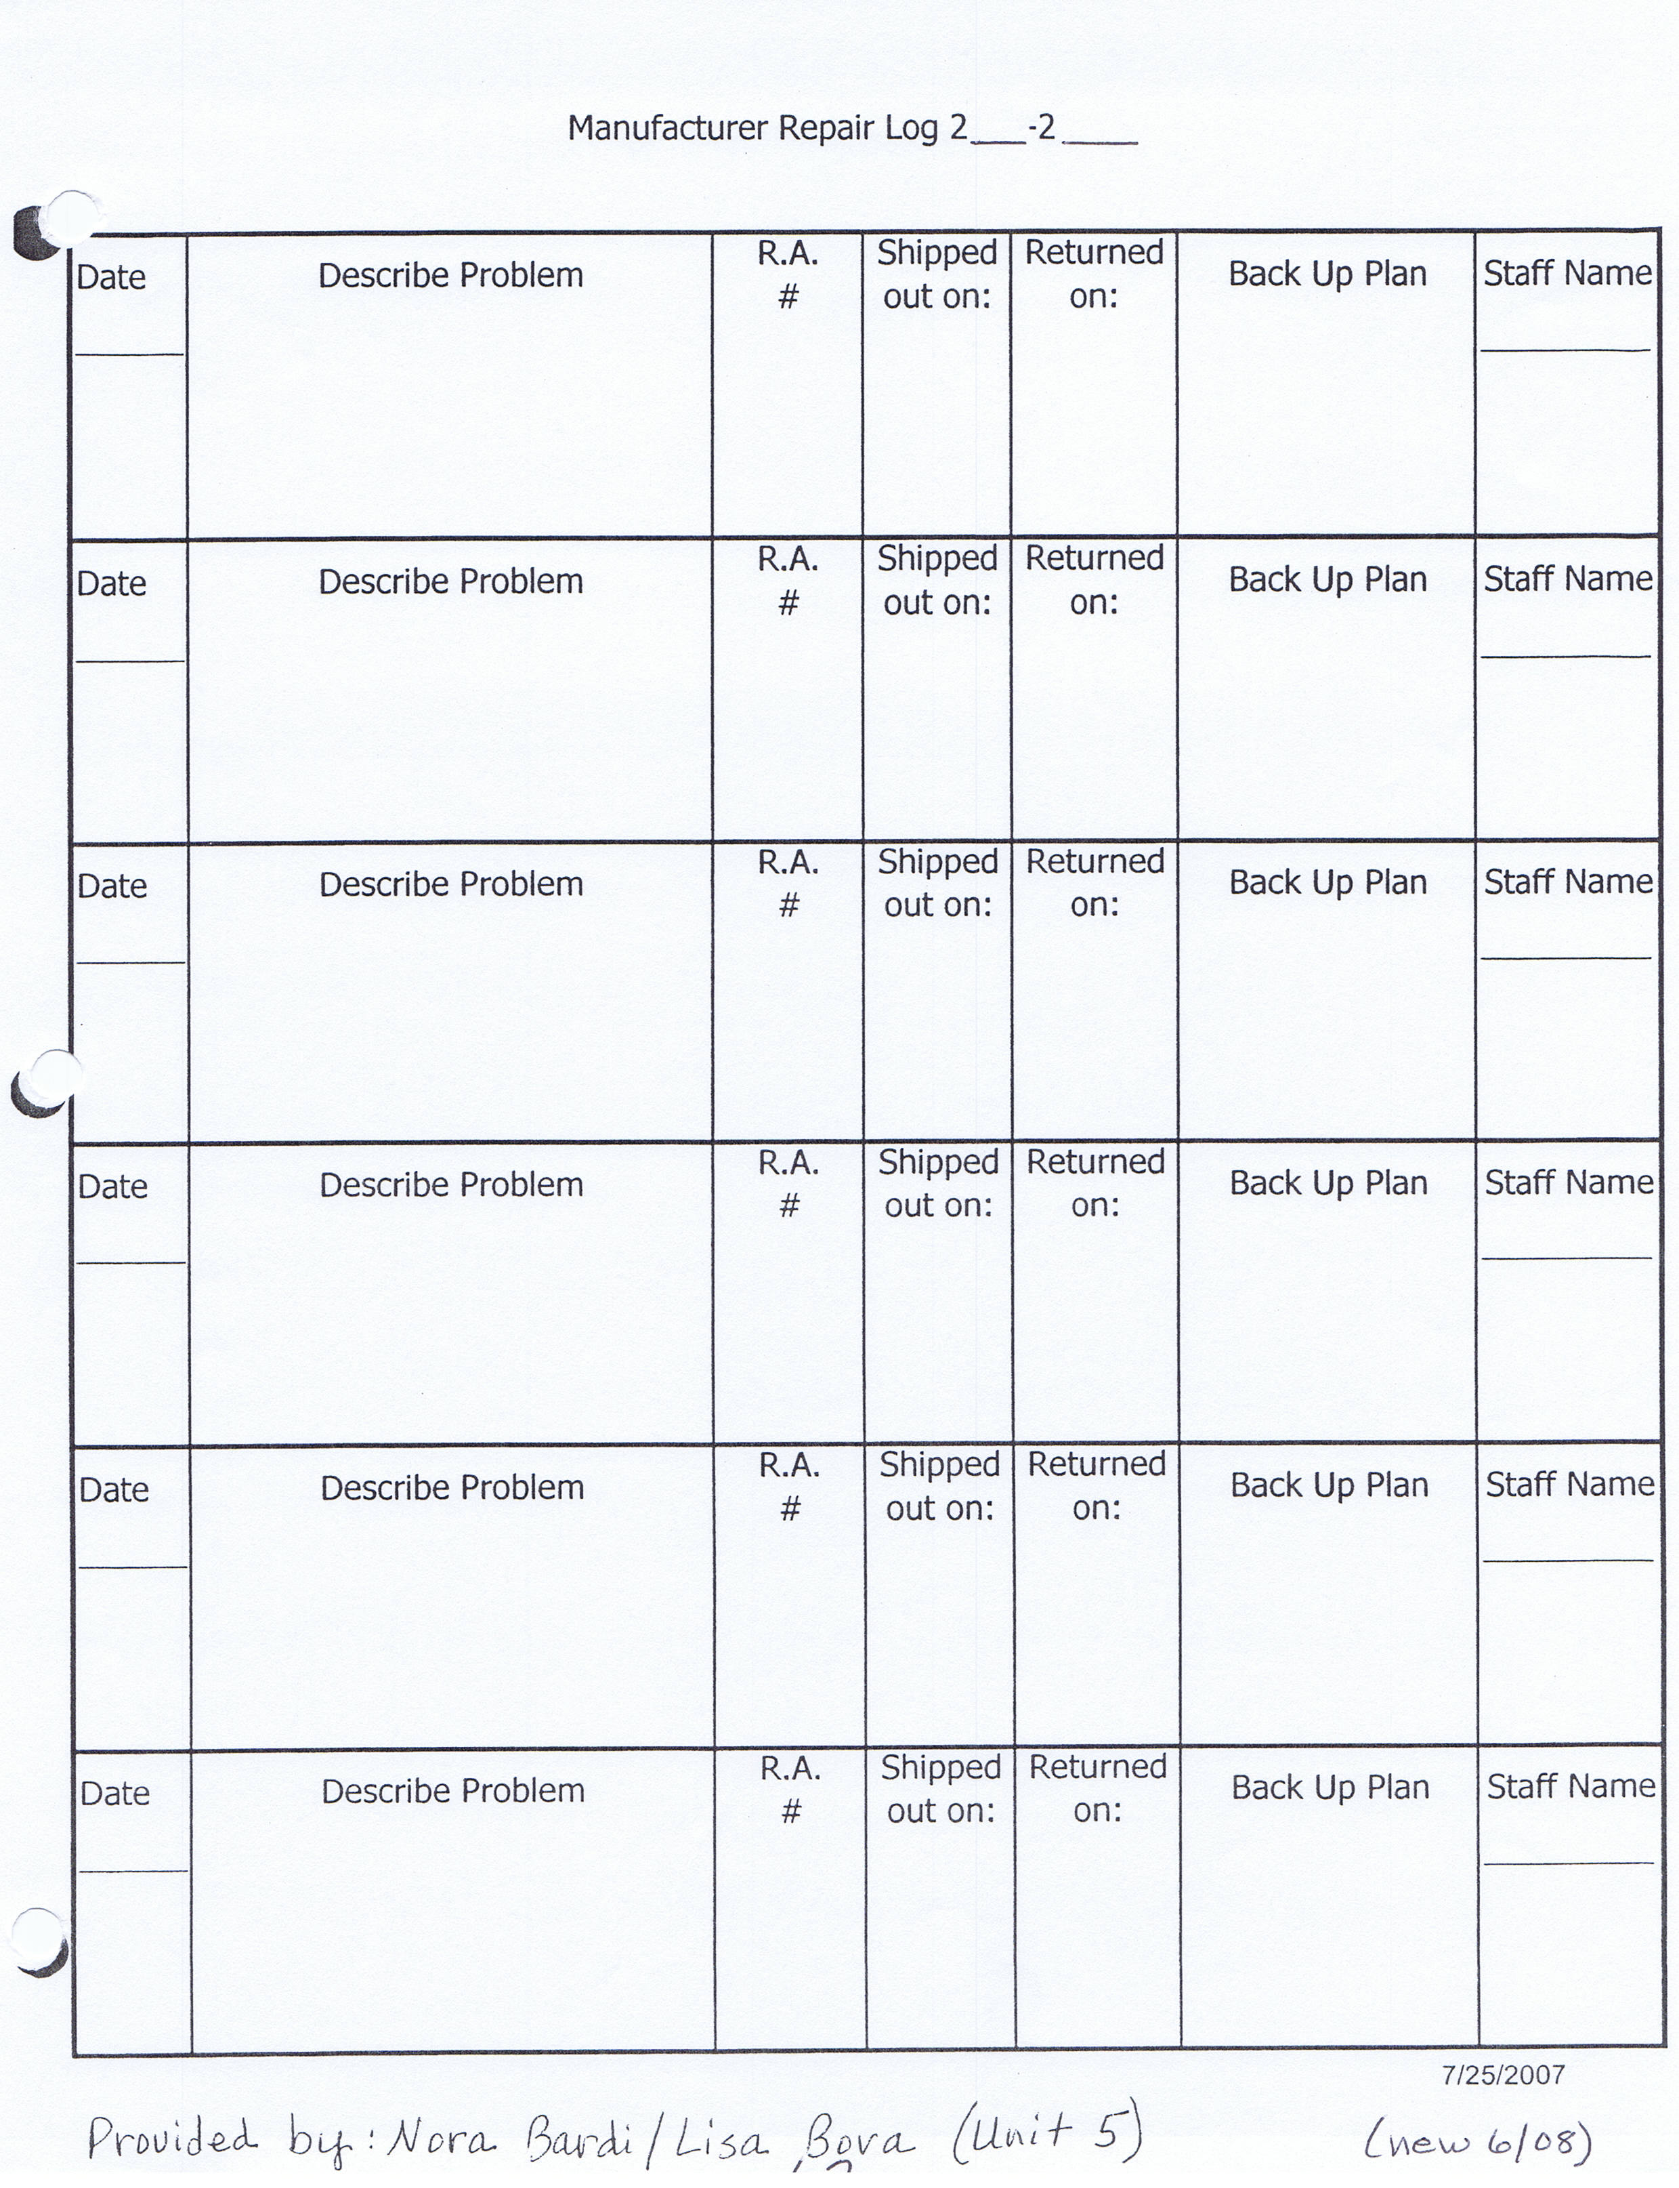
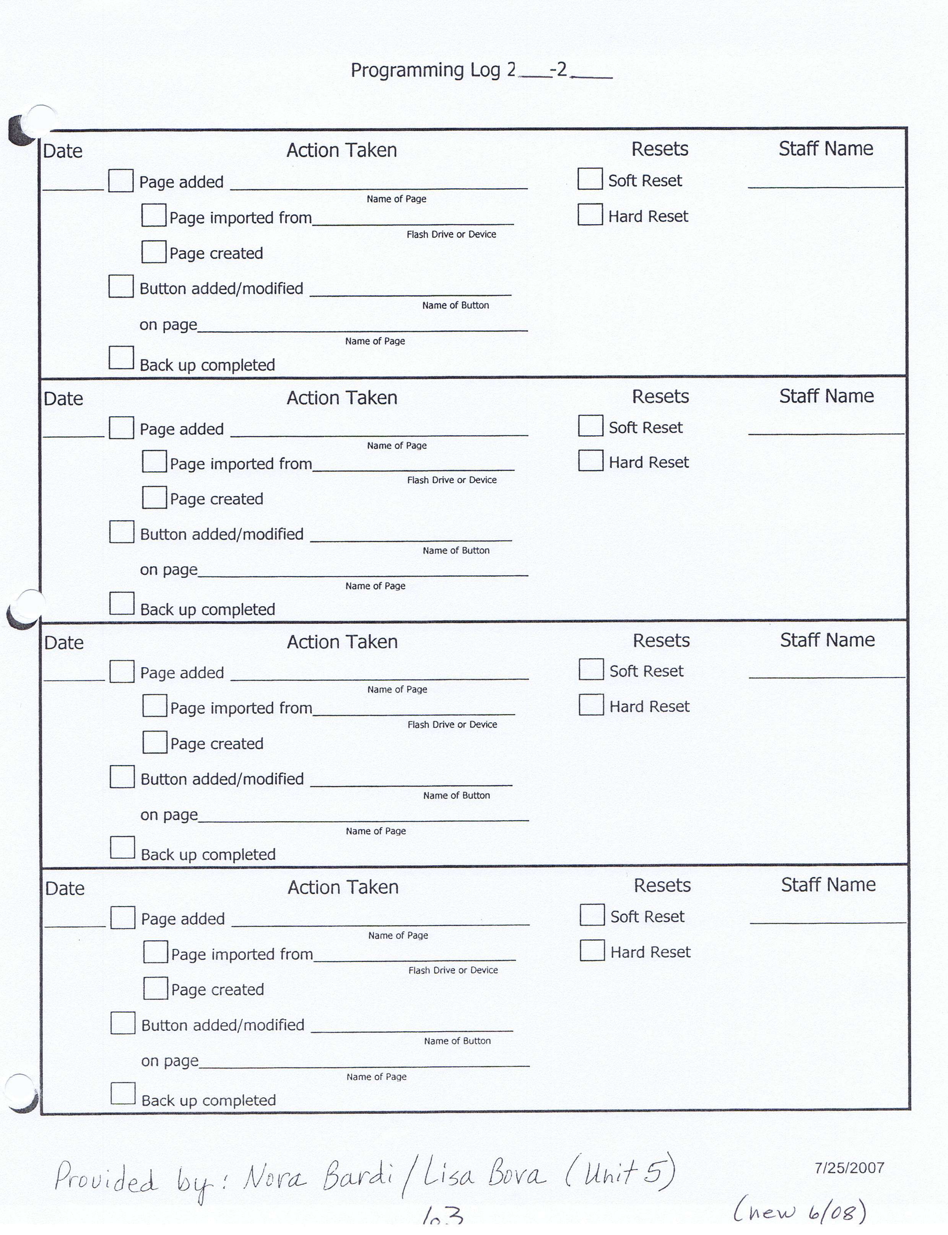
Dysphagia Protocol: Table of Contents
p. D1 Introduction
Procedures:
p. D2 Developing a Feeding and Swallowing Plan
p. D3 Feeding and Swallowing Procedures: Flowchart
p. D4 The IEP and Feeding and Swallowing Plans
p. D5 When the Plan is Effective
p. D6-D9 When the Plan is not Effective
p. D10 Feeding and Swallowing Evaluation
p. D11 Swallow Study Referral

Documents:
pp. D12-13 Student Feeding and Swallowing Plan
p. D14 Daily Documentation Form
p. D15 Notification of Feeding and Swallowing Concerns
pp. D16-D17 Feeding and Swallowing Evaluation: Parent Questionnaire
pp. D18-D22 Feeding and Swallowing Evaluation
p. D23 Primary Care Provider Authorization: G-Tube Feeding Public School
Setting
Form: Sample Letter
Information:
p. D24 List of Videofluoroscopic Swallow Study Providers
pp. D25-D26 Understanding the Videofluoroscopic Swallow Study
p. D27 Additional Resources available at Tri-County

Introduction
Tri-County Special Education Association recommends the application of the following “Feeding and Swallowing Procedures,” for students in its member districts with feeding/swallowing needs. The following is included in the procedures: how to document a feeding plan, education of staff and communication between staff, how to address concerns and student safety, and how to make a referral for further evaluation.
TCSEA Feeding & Swallowing Procedures
The process of developing these procedures began as a result of
- Increased medical issues among students in member districts
- Concerns: Are we meeting student needs consistently?
- Uncertainty of staff to refer or treat
- Disagreements among staff and families
- Questions about when and how to refer for a feeding or swallowing evaluation
The overriding focus is on safety and nutrition while improving students’ eating/swallowing skills, mealtime behaviors and independent functioning.
These procedures are designed to promote a systematic approach to the:
- Development of feeding & drinking adaptations
- Documentation of feeding & drinking adaptations
- Consistent use of feeding & drinking adaptations
- Communication of adaptations during staff change or student classroom change
- Evaluation of feeding and swallowing difficulties
- Problem solving among team members

The following resources were utilized in the development of these procedures:
- Macomb Intermediate School District
Clinton Township, Michigan
“Feeding and Swallowing Procedures”
- American Speech-Language-Hearing Association
“Guidelines for Speech-Language Pathologists Providing Swallowing and Feeding Services in Schools”
Written by: the Working Group on Dysphagia in Schools, sponsored by ASHA
- American Speech-Language-Hearing Association
“Avoiding Disputes in School-Based Management of Students with Dysphagia: Five Key Strategies”
Written by: Bailey and Lugg

D1

Developing a Feeding and Swallowing Plan
The following procedures should be followed in order to meet student needs. Please refer to the Feeding and Swallowing Procedures: Flowchart (page 3) for an overview of these procedures. A feeding and swallowing plan is written and implemented for students who require any feeding or drinking adaptation for either therapeutic or safety reasons. Use Student Feeding and Swallowing Plan (pp. A&B). Adaptations may encompass simple accommodations or more significant modifications. All members of the feeding team should receive appropriate training and instruction. Training may be provided by parents, SLP, OT, other.

The SLP (after consulting with district administration), may decide to conduct annual feeding/swallowing screenings for high-risk students.

The feeding and swallowing plan is written by the IEP team, under the direction of the SLP and/or OT, according to medical recommendations, parent input and the parent and teacher’s experience with how the student eats and drinks most effectively. No further evaluation is needed in most cases. The plan is then implemented and the team determines whether it is effective. The SLP or OT conducts periodic monitoring of the feeding plan. The feeding team utilizes a Daily Documentation form (pg. C). Each daily documentation form is completed and placed in the student’s file by the case manager. The plan is considered effective when the student appears to be eating and swallowing safely; without symptoms such as:
- Coughing or gagging during meals
- Choking
- Vomiting
- Wet sounding vocalizations
- Gurgly sounding respiration
- Very fussy eating behaviors- Refusal of foods/liquids
- Spikes in temperature
- Chronic ear infection
- Chronic respiratory problems (pneumonia)
- Watery eyes
- Prolonged feeding time (more than 30 minutes)
- Shortened feeding time (less than 10 minutes)
- Runny nose while eating
- Inability to transfer food from plate to mouth effectively
- Poor oral control of bolus (i.e. anterior labial loss, pocketing, etc.)
- Gasping – stridor
- Reddening around the eyes
This plan is considered not effective when the staff or family continue to report the above symptoms or difficulties.

D2

Feeding and Swallowing Procedures: Flowchart
Feeding and Swallowing Plan Written and Implemented
***DAILY DOCUMENTATION FORM IS USED BY FEEDING TEAM and FILED***
Plan is effective Plan is not effective
Student appears to be eating and Student demonstrates symptoms of
swallowing successfully difficulty feeding and swallowing

Review plan at each IEP, put copy of plan Effective Observation by SLP/OT/PT
In Student file AND Tri-County file Make suggestions to adapt feeding plan

Changing Classrooms Not Effective

Notify principal, S/L Supervisor,
TAS, and parent of request
for an evaluation.
New Teacher reviews plan Develop & implement temporary
feeding plan

If needed, the previous teacher or SLP/OT Formal Feeding and Swallowing
may demonstrate feeding plan & use of daily Evaluation by SLP/OT
documentation form for new team.
Effective

Hold IEP Team requests
meeting & information from
develop a outside sources at
feeding plan any time after
feeding evaluation
(e.g. swallow study
or dietician)
Implement
feeding plan
Not Effective
Effective If concerns The IEP team will hold a
Continue as above arise, return to first follow-up meeting in a timely
procedure (top) manner and design a new plan
D3

The IEP and Feeding and Swallowing Plans

Documenting Effective Plans in the IEP
A Feeding and Swallowing Plan needs to be documented in the IEP.
Record statements of performance and needs on the IEP section for Present Levels of
Performance, under Speech-Language Communication Skills, Functional
Performance or Motor/Sensory/Health development.

- Strengths: “Student Feeding and Swallowing Plan has been developed, and is attached to this IEP. Implementation of the plan is required for safe eating/drinking. The plan will be modified as needed.” You may also add specific strengths as related to feeding and swallowing.
- Needs: “Implement Student Feeding and Swallowing Plan.” You may also add specific needs as related to feeding and swallowing.

Documenting Concerns in the IEP
The following should be written in the IEP if there are feeding/swallowing concerns at the initial IEP meeting, or the annual review IEP meeting.
Record statements of performance and needs on the IEP section for Present Levels of Performance, under Speech-Language Communication Skills, Functional Performance or Motor/Sensory/Health development.
- Strengths: “Student is demonstrating symptoms of difficulty feeding and swallowing.” A temporary plan has been developed, and is attached to the IEP. Implementation of the temporary plan is required for safe eating/drinking.”
- Needs: “Implement temporary Student Feeding and Swallowing Plan until a long term Feeding Plan is developed.”

Documenting Concerns throughout the duration of the IEP
When feeding/swallowing concerns occur throughout the duration of the IEP, the team will convene for an IEP meeting, and document concerns, discussion and decisions on an addendum page. If one is developed, attach a temporary feeding plan, or a new long term feeding plan to the addendum page. File appropriately. (If changes are made to the IEP itself, then copy the entire IEP and attach to addendum page).
An IEP team (SLP, OT, Case Manager, Nurse, Cafeteria Personnel) may choose to meet on a regular basis to review safety, concerns, and plan menus for students who are on specific diets.

Documenting Intervention related to Feeding and Swallowing
IEP goals and objectives related to improved feeding and swallowing are written when the IEP team feels it is appropriate. These goals may be the responsibility of the SLP, OT, or teacher.
Goals may be written under several different instructional areas, such as:
- Self-help
- Oral – Motor
- Sensory

D4

When the Plan is Effective

The following steps should be followed if the feeding plan is effective and the student appears to be eating and swallowing successfully.

The feeding and swallowing plan should be referenced in the student’s IEP. See The IEP and Feeding and Swallowing Plans (p.4) for more about how to document this information. Appropriate staff should be made aware of the required adaptations and be provided with instruction if needed. A copy of the plan should be placed in the student’s file at school, and at Tri-County. The plan should be modified or updated as needed, and disseminated to the team, including the parents. The use of a Daily Documentation form (p.C) is recommended. The feeding team should complete the form on a daily basis, and place in the student’s file.

The feeding and swallowing plan should be reviewed once a year at the student’s annual review IEP meeting. The staff and family should make changes in the plan to reflect current feeding practices.

It is important that information related to the feeding plan be shared when any new staff members join the feeding team. Each new member should review the feeding plan. In addition, the speech-language pathologist, occupational therapist or other feeding team member will be asked to address questions and concerns related to the feeding plan. They will also be asked to demonstrate the feeding as well as use of the daily documentation form.

D5

When the Plan is Not Effective

The feeding plan is considered not effective when the student demonstrates symptoms of difficulty eating and swallowing. These symptoms may include:
- Coughing or gagging during meals
- Choking
- Vomiting
- Wet sounding vocalizations
- Gurgly sounding respiration
- Very fussy eating behaviors-Refusal of foods/liquids
- Spikes in temperature
- Chronic ear infection
- Chronic respiratory problems (pneumonia)
- Watery eyes
- Prolonged feeding time (more than 30 minutes)
- Shortened feeding time (less than 10 minutes)
- Runny nose while eating
- Inability to transfer food from plate to mouth effectively
- Poor oral control of bolus (i.e. anterior labial loss, pocketing, etc.)
- Gasping – stridor
- Reddening around the eyes

It is imperative that staff recognize these symptoms as potential swallowing problems and initiate appropriate steps to alleviate the symptoms, as follows:

If the feeding plan is not effective, the SLP or OT should be contacted. The SLP or OT will discuss the concerns with the feeding staff. In addition, they will review the Daily Documentation forms (p.C) supplied by the feeding staff. At this time, the SLP or OT may make suggestions to adapt the feeding plan. This action alone may result in safe and successful feeding as demonstrated by reduced symptoms of feeding difficulty. If safe feeding is once again established, the new feeding plan is documented in the IEP.

If the feeding and swallowing concerns continue, the SLP or OT should notify the building principal, Tri-County Speech/Language Supervisor, Tri-County TAS and parent of the concerns and the recommendation for further evaluation or input from professionals. See Notification of Feeding and Swallowing Concerns (p.D).

NOTE: Not all Speech-Language Pathologists (SLPs) or Occupational Therapists (OTs) have adequate training or experience in conducting a feeding evaluation. It is important that they feel confident in their skill level in this area. It may be necessary for a district to obtain services from a qualified SLP and/or OT at extra cost.

D6

When the Plan is Not Effective (Continued)

A temporary feeding plan will be designed and implemented until a formal feeding plan is in place. This temporary plan is written on a Student Feeding and Swallowing Plan (pp. A&B) with “temporary plan” checked and dated on the upper right side.

The temporary plan may include minor adaptations such as limiting portions or consistencies as tolerated. When more serious concerns exist, the district Superintendent may choose to consult with legal council to help determine if the child will not be fed orally at school, or if the family will be asked to feed the student on school premises until an effective plan is developed and implemented. It is recommended that the family consult their doctor or dietician to assist in developing the temporary feeding plan.

On the Notification of Feeding and Swallowing Concerns (p.D) the feeding team may recommend one of the following:

Feeding and Swallowing Evaluation:
If this is the recommendation, the Feeding and Swallowing Evaluation form (pp. G-K) is completed by the evaluator. The information is gathered through discussions with feeding staff, review of Daily Documentation forms (p.C) and direct evaluation with the student. In addition, the evaluator reviews the input provided by the parents on the Feeding and Swallowing Evaluation-Parent Questionnaire (pp. E&F). The evaluator then makes recommendations for feeding and swallowing. A new Student Feeding and Swallowing Plan (pp. A&B) is written and implemented by the team.

Physician Input:
If this is the recommendation, the feeding team may request evaluation input, clarification of previous input or a prescription from the student’s physician. The educational team should utilize the Consent for Exchange of Confidential Information form.

A signed physician approval is required before a change in food/drink consistencies can be made.

D7

When the Plan is Not Effective (Continued)

Dietician Input:
If this is the recommendation, the family will be asked to contact a dietician. A dietician can provide information such as:
- Foods that provide additional calories for those students who are failing to thrive
- Amount of calories needed per day in order to achieve target body weight
- Ounces safely consumed orally, if a student is tube fed, just to provide “pleasure foods”
- Ideas for introducing different textures into a child’s diet

Videofluoroscopic Swallow Study:
If this is the recommendation, the parents will begin by speaking with their physician about obtaining a prescription for a swallow study. This usually occurs when the gathering of input, evaluations and attempts to modify the feeding plan have not resulted in what the team considers an effective feeding plan.

When a swallow study is suggested, the team will provide pertinent information to the family. This will include: the concerns, using Notification of Feeding and Swallowing Concerns (p. D) and Daily Documentation forms (p.C). Also, Understanding the Videofluoroscopic Swallow Study (in the Information section) and Swallow Study Providers (p.L). The family is asked to sign a release of medical information, using the Consent for Exchange of Confidential Information form (in the Information section). The parent then obtains a prescription from the physician for the videofluroscopic swallow study. A letter (example in Information section) and appropriate supporting documentation, is sent to the physician explaining the request.

The family selects a medical facility based on their physician’s referral and insurance coverage. The SLP and/or OT may make arrangements to attend the swallow study with the student.

After outside information is gathered
After the evaluation and any outside information is gathered, and IEP meeting is held to discuss results and to design a feeding plan. The feeding plan is implemented and continued as long as it is effective.

D8

When the Plan is Not Effective (Continued)

Other considerations:

- A temporary feeding plan should be short term and used only as long as it takes to complete or obtain an evaluation, results, or a meeting. The temporary feeding plan is developed by the educational team, including the parents.
- In more serious situations, it is recommended that the school administrator consult district legal counsel for making decisions related to feeding the student at school.
It may be determined that until the appropriate action is taken (i.e. swallow study; physician input, etc):
- The educational team will no longer be responsible for feeding the student at school.
- The student’s family will feed the student on school premises, or
- The student will not be fed orally at school.

D9

Feeding and Swallowing Evaluation

A Speech-Language Pathologist and an Occupational Therapist with the appropriate skills and experience in feeding and swallowing, will lead the evaluation. The feeding team may assist in the evaluation.

The evaluation includes information obtained from the Parent Questionnaire form (pp. E&F) and the following areas of assessment:

- Positioning
- Reflexes
- Tactile Responses
- Food Consistencies
- Food Preferences
- Therapeutic Spoon Feeding
- Oral Structures
- Oral Musculature During Chewing/Drinking
- Drinking
- Swallowing Concerns
- Response to Feeding

Information will be documented on the Feeding and Swallowing Evaluation form (pp. D18-D22).

D10

Swallow Study Referral

In some cases, a student continues to demonstrate symptoms of feeding and swallowing difficulties even after the team has completed an evaluation and despite various attempts to modify the way a student eats or drinks. In these cases the team may wish to recommend that the family seek a swallow study for the student.

The team may recommend that the parents seek a swallow study for the student at any point after the school team feeding and swallowing evaluation. The following steps are suggested:

- Designated team member contacts family, and uses Notification of Feeding and Swallowing Concerns form (p.D) to document the contact.

- Team provides:

- Information about swallow study/procedures (in information section).
- List of providers (in information section).

- Parent contacts physician for a prescription for a swallow study and makes the appointment.

- Parent informs school of pending appointment, location, date, and time.

- Designated team member obtains parent signature on the Consent for Exchange of Confidential Information form (in information section).

- Designated team member contacts the physician using the Letter, (in the documentation section). The team member attaches evaluations, and/or documentation supporting the concerns listed in the letter, as well as the signed Consent for Exchange of Confidential Information.

- Designed team member attends swallow study to share school information, obtain results, and help family interpret recommendations.

- Team reviews swallow study results and recommendations.

- Team meets with family to discuss results and develop new feeding plan

D11

Student Feeding and Swallowing Plan

Date _____________________
Review Date _______________
Review Date ________________
Temporary Plan _____________
Student ________________________________________Case Manager ______________________________________________

Primary Implementer or Feeding Assistant ____________________________________________________________________
Feeding Team Members ____________________________________________________________________________________
_________________________________________________________________________________________________________
Allergies __________________________________________________________________________________________________
Equipment Dish ______________________________________Utensil ____________________________________________
Cup ______________________________________ Straw _____________________________________________
Feeding Independent ________________ Assisted __________________________
Explain ______________________________________________________________________________________
_________________________________________________________________________________________________________
Food Consistency Pureed _______ Ground __________ Chopped _________ Mashed _________ Bite size _________________
Liquids No liquids ______________ Thickened liquids _____________
Nectar Consistency _____________ Honey Consistency _____________ Pudding Consistency _____________
Special Instructions__________________________________________________________________________________________
__________________________________________________________________________________________________________
__________________________________________________________________________________________________________
Tube Fed _______
Tube fed/Nothing by mouth _________ Tube and Oral Fed __________ Amount fed Orally ________________
___________________________________________________________________________________________________________
PROCEDURES
Amount of food per bite _______________________________________________________________________________________
Food placement _____________________________________________________________________________________________
Wait time between bites _______________________________________________________________________________________
Behavior Techniques _________________________________________________________________________________________
Phrases Used _______________________________________________________________________________________________
Student’s Communication or signals during feeding _________________________________________________________________
___________________________________________________________________________________________________________

D12

Student Feeding and Swallowing Plan
____Keep student in upright position ______ minutes after meal
____ Encourage student to cough to clear throat ___Offer a drink after ____ bites
Other _____________________________________________________________________________________________________
__________________________________________________________________________________________________________
POSITIONING
1. Sitting posture _______________________________________________________________________________________

- Chair/seating device __________________________________________________________________________________

- Head position/support _________________________________________________________________________________

- Trunk control/support _________________________________________________________________________________

- Other ______________________________________________________________________________________________

Check here if there is ongoing Oral Motor Program ______ (See Therapist/Plan)

The following team members participated in the development or review of this feeding plan:

Sign and Date:

________________________________________________ _____________________________________________________

________________________________________________ _____________________________________________________

________________________________________________ _____________________________________________________

________________________________________________ _____________________________________________________
D13

Daily Documentation Form For the Week beginning: __________________
Student: ___________________________ Reviewed by: ____________________________

Date: _________ B-fast Lunch Snack Date: _________ B-fast Lunch Snack
Feeder Initials: ____________ Feeder Initials: ____________
Symptoms/Comments: Symptoms/Comments:

Date: _________ B-fast Lunch Snack Date: __________ B-fast Lunch Snack
Feeder Initials: ____________ Feeder Initials: ____________
Symptoms/Comments: Symptoms/Comments:

Date: __________ B-fast Lunch Snack Date: ___________ B-fast Lunch Snack
Feeder Initials: ____________ Feeder Initials: ___________
Symptoms/Comments: Symptoms/Comments:

Date: __________ B-fast Lunch Snack Date: ___________ B-fast Lunch Snack
Feeder Initials: ____________ Feeder Initials: ___________
Symptoms/Comments: Symptoms/Comments:

Date: __________ B-fast Lunch Snack Date: ___________ B-fast Lunch Snack
Feeder Initials: ____________ Feeder Initials: ___________
Symptoms/Comments: Symptoms/Comments:

D14

Notification of Feeding and
Swallowing Concerns

Designated team member does the following:
- Completes top half of this form and communicates concerns with building principal.
- Attaches copies of daily documentation forms that support these concerns.
- Contacts parent to share concerns.
- Writes parent responses on bottom half of this form.
- The IEP team will convene to discuss the recommended evaluation and to develop a temporary feeding plan.

Student _________________________________ Date ____________________

The following feeding and swallowing concerns have been identified
and documented by the feeding staff:

- _____________________________________________________
- _____________________________________________________
- _____________________________________________________
- _____________________________________________________
- _____________________________________________________
Further evaluation/input recommended:
____ Feeding/Swallowing Evaluation ____ Physician Input
____ Dietician Input ____ Videofluoroscopic Swallow Study

Contact with parent was made by _________________________________________
on _____________________.
(date)

Parent response: _______________________________________________
______________________________________________________________
______________________________________________________________
D15

Feeding and Swallowing Evaluation
Parent Questionnaire

Student_____________________________________________ Date of Birth_____________________________
Current Height and Weight________________________________Physician______________________________
Allergies____________________________________________________________________________________
___________________________________________________________________________________________
Does your child feed himself/herself?
□ Yes, independently □ Yes, with assistance □ No
Does your child enjoy mealtime? _________________________________________________________________
___________________________________________________________________________________________
How do you know when your child is hungry? full? __________________________________________________
___________________________________________________________________________________________
___________________________________________________________________________________________
Does your child take medication? Solid or liquid form? Any special instructions?___________________________
___________________________________________________________________________________________
How long does it take your child to complete a meal?
□ 10-20 min. □ 20-30 min. □ 30-40 min. □ 40-50-min. □ >60 min.
Does your child have difficulty with any of the following?
□ Choking during a meal □ Tongue thrust □ Very fussy eating behaviors
□ Coughing with or without spraying of food □ Swallowing □ Spikes in temperature
□ Chewing □ Breathing □ Chronic ear infection
□ Noisy breathing □ Gurgly or “wet” voice □ Chronic Respiratory problems
(pneumonia)
□ Gagging □ Vomiting □ Residue or pocketed Food
□ Biting on utensils

□ Being touched around the mouth Drooling: __ constant __frequent __occasional

Was or is your child fed through feeding tube?
□ Yes, currently □ Yes, previously □ No
If yes, list dates______________________________________________________________________________________
Why? □ Aspiration □ Medication only □ Transition to Oral Feeding □ Liquids only □ Other
Explain_____________________________________________________________________________________________

D16

Feeding and Swallowing Evaluation
Parent Questionnaire
What are your child’s food preferences?
Likes Dislikes
_____________________________________ _________________________________
_____________________________________ _________________________________
_____________________________________ _________________________________
_____________________________________ _________________________________
_____________________________________ _________________________________
What kinds of food does your child eat?
□ Liquids □ Thickened liquids □ Pureed □ Mashed □ Ground
□ Chopped □ Bite-sized pieces □ Table foods (whatever your family is eating)
Does your child take any nutritional supplements?
□ Yes □ No If yes, specify______________________________________________________
Do certain foods/liquids appear to be more difficult for your child to eat? __________________________________
___________________________________________________________________________________________
How is your child positioned during feeding?
□ Sitting in a chair at a table □ Sitting in a wheelchair □ Sitting □ Held on lap
□ Reclined □ Lying down □ Other
What Utensils are used?
□ Bottle □ Spoon □ Sippy cup □ Cup (no lid)
Other adaptive equipment_______________________________________________________________
Has your child ever had a swallow study?
□ Yes □ No If yes, when?_________________________________________
What were the results? _______________________________________________________________________
___________________________________________________________________________________________
Additional Comments or Concerns: ______________________________________________________________
___________________________________________________________________________________________

______________________________ _______________________________
Parent Signature Date

D17

Feeding and Swallowing Evaluation

Student_________________________________________________________Date________________________
Evaluator(s)/Title(s) ____________________________________________________________________________
Classroom Teacher____________________________________________________________________________
POSITIONING:
 | Concerns | Recommendations
Hips

Trunk

Head/Neck

Arms/Hands

Legs/Feet

List Seating Equipment Used____________________________________________________________________
___________________________________________________________________________________________
REFLEXES:
Gag reflex: __Normal __Hyper __Hypo __Absent
Bite reflex: __Normal __Hyper __Hypo __Absent
Rooting: __Yes __No

D18

Feeding and Swallowing Evaluation
TACTILE RESPONSES
 | Response to Stimulation | Recommendations
Body

Face

Mouth

Lips

Tongue

Teeth

FOOD CONSISTENCIES □ Pureed □ Ground □ Mashed □ Chopped □ Bite size
□ Mixed (indicate consistencies of mixtures)_________________________________________
_________________________________________________________________________________________________________
FOOD PREFERENCES List any food preference related to:
Texture_________________________________________________________________________________________________
Taste___________________________________________________________________________________________________
Temperature (i.e. hot/cold/warm)_____________________________________________________________________________
Reaction to non-preferred foods______________________________________________________________________________
THERAPEUTIC SPOON FEEDING Spoon Use
Removes food with □ suckle □ suck
Waits quietly for spoon □ yes □ no
Opens mouth when food is presented □ yes □ no
Active participation in removing food □ yes □ no
Lips assist □ yes □ no
Moves food posteriorly well □ yes □ no
Lick lips clean □ yes □ no
Position of tongue when spoon is present □ thin & cupped □ humped □ posterior
Amount consumed _____________________ in ______________ minutes
Recommendations_________________________________________________________________________________________
________________________________________________________________________________________________________
D19

Feeding and Swallowing Evaluation
ORAL STRUCTURES & MUSCULATURE DURING CHEWING:
 |  | Concerns | Recommendations
Jaw | Movement  __________________________  Bite Alignment/Pattern | _________________________________ | ____________________________
Teeth

Tongue | Elevation  __________________________  Left lateralization – moves from  tongue to chewing surface &  from side to side  __________________________  Right lateralization – moves from  tongue to chewing surface & from side to side  __________________________  Front-to-back Movement – moves food posteriorly  __________________________  Protrusion/Thrust | _________________________________  _________________________________  _________________________________  _________________________________ | ______________________________  ______________________________  ______________________________  ______________________________
Lips

Palate

Drooling □ yes □ no

Comments_____________________________________________________________________________
_____________________________________________________________________________________
D20

Feeding and Swallowing Evaluation
DRINKING:
Liquid Consistencies □ Unthickened □ Nectar □ Honey □ Pudding
Moves liquid with □ suckle □ suck □ unable to use cup
Tongue thrust □ yes □ no
Tongue retraction □ yes □ no
Anterior loss □ none □ minimal □ excessive
Appropriate jaw opening □ yes □ no
Jaw thrust □ yes □ no
Stabilizes cup by □ tongue under cup □ biting cup □ other
Upper lip closes over cup □ yes □ no
Up/down sucking motion □ yes □ no
Coordinated breathing with
sucking/swallowing □ yes □ no

Type of cup needed __________________________________________________________________________________
Response to thickened liquids__________________________________________________________________________
Recommendations___________________________________________________________________________________
SWALLOWING CONCERNS:
□ pneumonia or history of pneumonia □ gagging
□ delayed swallow □ coughing
□ multiple swallows □ wet voice
□ chronic low grade fever □ congestion
□ chronic, copious, clear secretions □ concerns related to weight
□ oral cavity not clear after swallow □ tongue pumping
□ larynx does not elevate properly
RESPONSE TO FEEDING:
□ alert throughout □ lethargic □ irritable
□ facial grimacing □ anxious □ irregular or audible breathing
□ refusal □ vomiting □ increased hypertonicity
□ reflux □ fatigue □ facial reddening
Other________________________________________________________________________

________________________________________ ________________________________________________
Completed by/Title Completed by/Title

D21

Feeding and Swallowing Evaluation
Positioning for Feeding:
Checklist:
____ Body symmetrical
____ Head upright
____ Arms supported
____ Pelvis anchored and squared
____ Hips flexed at 90 degrees
____ Thighs separated
____ Knees flexed at 90 degrees
____ Feet supported and ankles neutral

Other: ________________________________________________________________
______________________________________________________________________
______________________________________________________________________
______________________________________________________________________
Completed by/Title:
_____________________________________________________________________________

D22

Primary Care Provider Authorization: G-Tube Feeding
Public School Setting
Student: _______________________________ Date of Birth: __________________
School Year: __________ District/School : _______________________________________________
Type of G-tube: Pump to be used:
____ Button ____ Yes
____ Catheter ____ No
____ Other (Specify): ____ Flow rate ________cc/hour
Name of formula: ________________________________________________________
Type of Pump: ________________________________________________________
Gravity: ____Yes ____ No Volume to be given: ______ cc over ______minutes
Volume of water to follow feeding: _______ cc
Feeding times(s): ______ _______ _______ _______ _______
Positions: During feeding: __________________________________________
After feeding: __________________________________________
Note to Health Care Provider/Parent/Guardian:
- The parent/guardian will be notified if a tube becomes clogged or dislodged.
- School personnel cannot forcefully flush or replace a tube into the stomach.
- The school nurse may: ____forcefully flush OR ____replace a tube into the stomach.
- Feeding formula must be sent to school in the original unopened container.

Additional health care provider’s comments: ________________________________________________________________________________________________________________________________________________

__________________________________ ____________________________
Printed Name of MD ______________________________
Address

__________________________________ _____________________ __________
Signature of MD Telephone number Date
*Note to parent/guardian: Signing this form shall release the above listed School District and staff, as well as Tri-County Special Education Association and staff from liability of any nature that might result from this plan of action. I hereby give permission for the above information to be verified with the above health care provider.

_____________________________________________ _____________________ __________
Signature of Parent/Guardian Telephone Number Date
_________________________________ ____________________ __________
Emergency Contact Telephone Number Relationship to Child
D23

Date_________________________

To Whom It May Concern:
You have an appointment to see our student:
Name__________________________________ Birth Date_______________________
Diagnosis _______________________________________________________________
Our concerns include:
1.
2.
3.
We have included our most recent feeding and swallowing evaluation to provide you with current information.
We have included a Tri-County Special Education Association Consent for Exchange of Confidential Information form, signed by the parent. In your treatment plan, please provide information to help the school feeding team develop the optimal and safest diet level and compensatory feeding and positioning strategies. Please provide us detailed information related to:
- Safest solid and liquid consistency
- Safest volume and rate presentation
- Describe any compensatory strategies attempted and their effectiveness
Sincerely,

Name/Title
_________________________

_______________________
_______________________
Address
____________________________
____________________________

Videofluoroscopic Swallow Study Providers
The following constitutes a partial listing of community agencies offering swallow studies. This is not intended as an endorsement of any specific provider.

Abraham Lincoln Memorial Hospital Lincoln
Bromenn Hospital Normal
Carle Foundation Hospital Champaign
Decatur Memorial Hospital Decatur
Memorial Medical Center Springfield
Methodist Medical Center Peoria
Proctor Hospital Peoria
Provena Covenant Medical Center Urbana
St. Francis Hospital Peoria
St. Johns Hospital Springfield
St. Joseph Medical Center Bloomington
St. Mary’s Hospital Decatur

D24

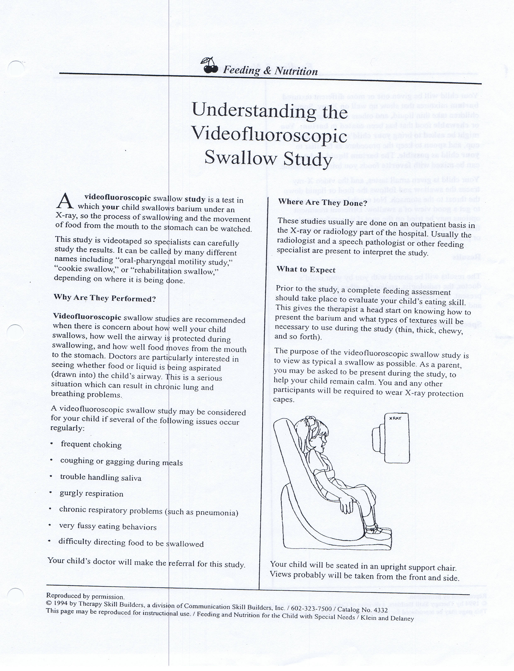
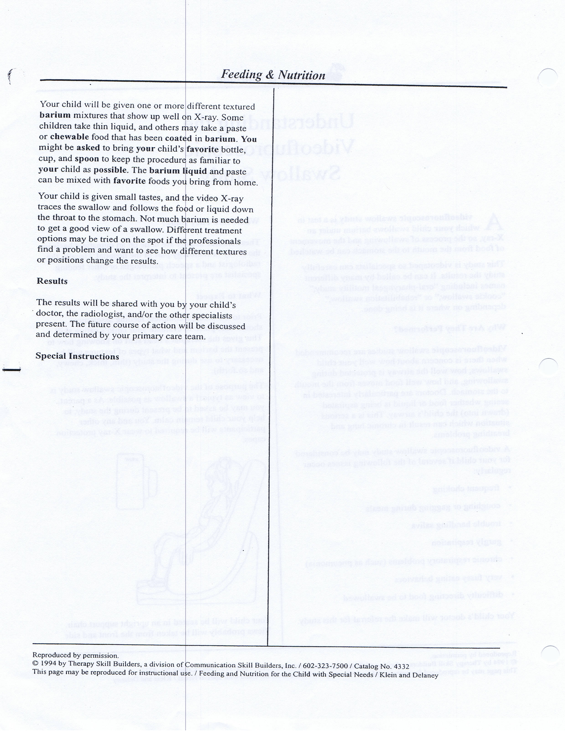

Additional Resources

- ASHA – Guidelines for SLPs Providing Swallowing and Feeding Services in the Schools 2007
- Avoiding Disputes in School-Based Management of Students with Dysphagia: Five Key Strategies (Rita Bailey & Elizabeth Lugg)
- ISHA – Development of a School-Based Feeding/Swallowing Safety Protocol
- Feeding and Swallowing Procedures (Macomb, Michigan) includes examples of:
Environmental modifications
Oral-motor goals
Oral-sensory goals
Therapy activities
Oral-motor stimulation program
Therapeutic feeding techniques
- Sample Reports for the management of dysphagia in the school setting

*********Please contact Joyce Dachauer, S/L Services Supervisor at Tri-County Special Education Association for these resources ************

D27

